Name __________________________Date___________ Born to Rope 1
Sounds: L S R DPT VD |  | Teach and Test
1. pocket___  2. spoon ___  3. tickle___  4. self_____  5. warm____ | 6. cloud_____  7. travel______  8. whole_____  9. have _____  10. joys_____ | 11.__________________________  12.__________________________  13.__________________________  14.__________________________  15.__________________________
1._____________________________  2._____________________________  3._____________________________  exhibition, imitated, thousand, ranch, landscape business, dappled,  - _______________– marked with spots or patches of light and dark  - ___________________– a show for the public  - _________________ copied something or someone  - _______________– a company that makes money by designing, shaping, and planting gardens for customers  - _______________– a large farm for raising horses, beef cattle, or sheep  - _______________ - whole numbers, written 1,000, 2000, and so on that are equal to 10 times 100, 200, and so on |  | 4.___________________________  5.___________________________

Daily Oral Language – Correct the each sentence, then write it on the line.
1. i is going to the hendrix parK to played bale

______________________________________________________________

2. do yous likes the painting about donald ducK
______________________________________________________________

Name __________________________Date___________ Born to Rope 2
Sounds: L S R DPT VD |  | Teach and Test
1. noise____  2. swoop____  3. cabbage___  4. shore____  5. tide______ | 6. fright _____  7. scream______  8. choose_____  9. clown_____  10. charm______ | 11.__________________________  12.__________________________  13.__________________________  14.__________________________  15.__________________________
1.____________________________  2.____________________________  3.____________________________  exhibition, thousand, ranch, landscape business, dappled, rhythm  - _________________– A company that plants flowers and trees.  - _________________– A farm with horses, cattle or sheep.  - _________________- It describes an animal with patches of color.  - _________________ - It is the beat in music, poetry or dance.  - _________________– It means a public show.  - _________________ - These numbers are larger than hundreds |  | 4.___________________________  5.___________________________

Daily Oral Language – Correct the each sentence, then write it on the line.

1. we visit they last tuesday in atlanta

_____________________________________________________________

2. me mom and me is goIng to the walmart
_____________________________________________________________

Name __________________________Date___________ Born to Rope 3
Sounds: L S R DPT VD |  | Teach and Test
1.worse _____  2. leaned______  3. chance______  4. broil______  5. boost_____ | 6.forest _____  7. eight______  8. stood_____  9. climb_____  10. pouch______ | 11.__________________________  12.__________________________  13.__________ ________________  14.__________________________  15.__________________________
1._____________________________  2._____________________________  3._____________________________  thousand, conductor, exhibition, landscape business, dappled, ranch  - There are ________________________ of people at the fair.  - My dad works for a _______________ ________________.  - The horses came form a nearby _________________________.  - Daisy, the horse, had a ____________________________ coat.  - I love to see the art __________________________ at the fair  - The __________________________ check the people’s train tickets. |  | 4.___________________________  5.___________________________

Daily Oral Language – Correct the each sentence, then write it on the line.
1. she did’nt went to sChool friday or monday

_____________________________________________________________

2. they was on a trip to sea bares and dear
_____________________________________________________________

Name __________________________Date___________ Born to Rope 4
Sounds: L S R DPT VD |  | Teach and Test
1. crank _____  2. scoop______  3. shred ______  4. charm______  5. count______ | 6. poach_____  7. moose______  8. joint_____  9. breath_____  10. germ______ | 11.__________________________  12.__________________________  13.__________________________  14.__________________________  15.__________________________
1.____________________________  2.____________________________  3.____________________________ |  | 4.___________________________  5.___________________________
created, thousands, exhibition, landscape business, dappled, ranch,
- We went to an ice skating (show) _________________________.
- The horse had a (spotted) __________________________ coat.
- The (gardening company) ____________________ planted all the trees.
- We have horses on our (farm) _________________________.
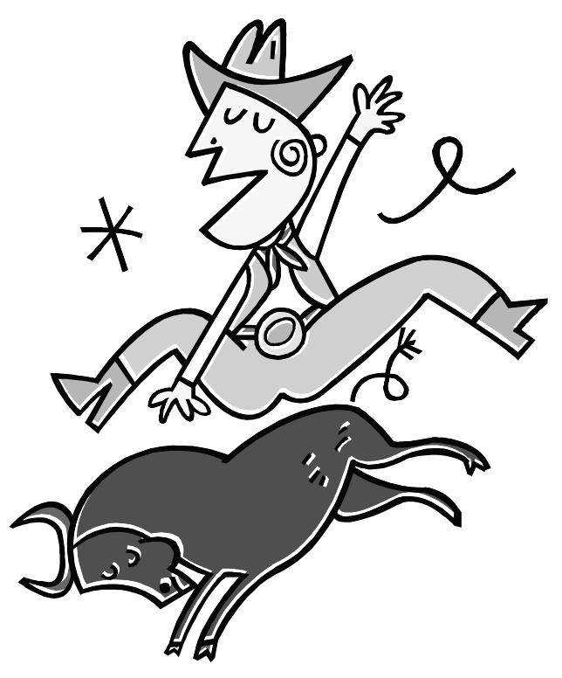
- The boy (made) ________________ a picture out of buttons and wire.
- (Numbers) ______________________ of buffalo roam the plains.

Daily Oral Language – Correct the each sentence, then write it on the line.
1. he come to the sho with i and harry

______________________________________________________________

2. when the story end i was sad
______________________________________________________________


Name __________________________Date___________ Born to Rope 5
Sounds: L S R DPT VD |  | Teach and Test
1. chime_____  2. south ____  3. smooth _____  4. thread______  - sport______ | 6. thrust_____  7. churn______  8. nurse_____  9. droop _____  10. sign ____ | 11.__________________________  12.__________________________  13.__________________________  14.__________________________  15.__________________________
1.______________________  2._____________________  3.______________________  landscaping, conductor, thousands, exhibition, dappled, ranch  - That ______________________ directed the music for the new movie.  - We are going to see the new dinosaur __________________.  - The _______________ pony can run like the wind.  - My family will spend our vacation at a dude _________________.  - ____________________ of birds fly south in the winter.  - The Smiths’ have a ________________________ business. |  | 4.___________________________  5.___________________________

Daily Oral Language – Correct the each sentence, then write it on the line.
1. he see the bird fli up in the clowd

_____________________________________________________________

2. did me dad remov the tag from my knew jaCket
_____________________________________________________________

