Name _________________________________ Spelling Frog and Toad
Multiple Choice Spelling Test
Directions: Look at each answer choice and circle the one that is spelled correctly.
huried | hurreid | hurried | hurryed
cryed | cied | cryied | cried
studied | studeyed | studeed | studyed
maryed | maried | married | marryed
copid | copyed | copied | copeed
carryed | caried | careed | carried
worried | worryed | woried | woryed
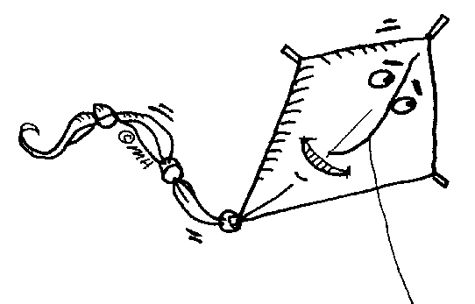  tirde | tried | tierd | tryed
fied | fruyed | fryed | fried
repied | repleid | relyed | replied

- ______________ chicken is my favorite food.
- I asked him a question, but he never ________________.
- The baby ____________________ for his teddy bear.
- Jim and Jane were _________________ in a big, white church.
- She ___________________ her math facts for the test.
- The children ___________________ to build a sand castle.
- The monkeys _____________________ the man with the caps.
- He was ____________________ that his kite wouldn’t fly.
- The mother cat _______________ her kitten to a safe place.
- The students _______________ inside when it started to rain.

