Name __________________________ From Seed to Plant Study Guide
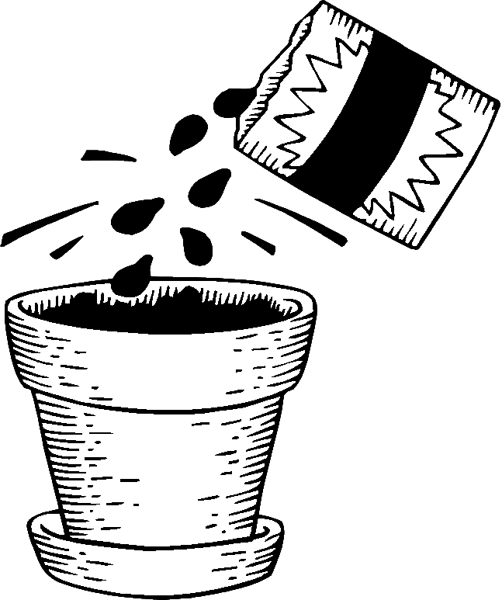
Write the correct word in the blank.
beautiful nutrition protects ripens streams

1. You can eat the apple when it __________________________
2. Your flowers are _________________________________
3. We saw fish in the __________________________
4. We need to eat many foods to have good ____________________
5. Some animals have a fur coat that ________________________ them from the cold.

1. Which plant part has the beginning of a new plant? _____________________

2. How do you know what kind of plant a seed will grow into? ________________

_____________________________________________________________

3. What do stamens make? ________________________________________

4. After flowers are pollinated, they ________________________________

____________________________________________________________

5. When are seeds ready to become new plants? ________________________

____________________________________________________________

6. What can move pollen and scatter seeds? ____________________________

7. List three ways that seeds get to different places: ____________________

_____________________________________________________________

_____________________________________________________________
_____________________________________________________________

8. How are a seed coat and the fruit or pod around a seed alike? ____________

_____________________________________________________________

_____________________________________________________________

9. List three things a seed needs to start growing: _______________________

_____________________________________________________________

10. Why does a seed need roots? ___________________________________

____________________________________________________________

11. When the seed begins to grow, it is called ___________________________

12. Why do people eat some seeds, fruits, and pods? ______________________

_____________________________________________________________

13. What genre is this selection? ____________________________________

14. How do insects move pollen from flower to flower? ____________________

_____________________________________________________________

15. Why did the author write this book? _______________________________






