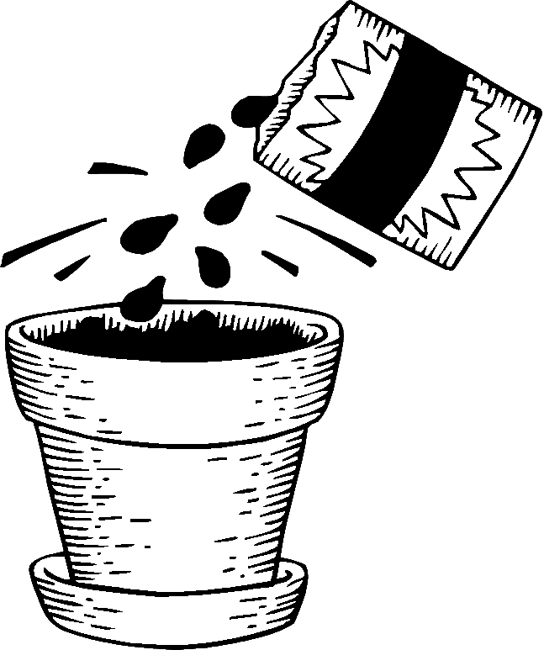
Name ________________________________ From Seed to Plant 1
Pollination pollinate plant Flowers different stigma kinds pollen
- A seed contains the beginning of a new _______________.
- Seeds are _______________ shapes, sizes and colors.
- All seeds grow into the same _______________ of plant that made them.
- _______________ are where most seeds are kept.
- Before a seed can grow a grain of _______________ must land on the _______________.
- _______________ happens with pollen lands on the top of the pistil.
- Insects and wind help plants to _______________.

ABC ORDER

___curled
___pollen
___pistil
___protect
___shore
___scatters
___stream
___ contain

1. _______________
2. _______________
3. _______________
4. _______________
5. _______________
6. _______________
7. _______________
8. _______________
SYLLABLES 1, 2, 3, 4,
1.germination_____
2.pollination _____
3.vegetables _____
4. different _____
5.acorns _____
6. protect _____
7. food _____
8. parachutes_____

Name _______________________________ From Seed to Plant 2
Tube flower seed pistil fruit dies insect’s nectar
1. Hummingbirds visit flowers for the sweet juice called ______________.
2. The pollen rubs onto the ______________ body.
3. They carry the pollen to another ______________ and it comes off onto its ______________.
4. The pollen grain grows a long ______________ to the ovule.
5. This is the beginning of a ______________.
6. The seed grows inside the flower even as the flower ______________.
7. As the seed becomes bigger, a ______________ or pod grows around them.

What’s the word.
1. ___ day - zee
a.dandelion
b.dusty
c.drummer
d.dinner
e.donor
f.damage g.disobey
h. depart
i. dimple
j. dabble

2. ___ dih - part
3. ___ dihm- pƏl
4. ___ dihs-oh-bay
5. ___ druhm - Ər
6. ___ dă - mihj
7. ___ dăn–dƏ –liy-Ən
8. ___ dă - bƏl
9. ___ doh - nƏr
10.___ duh - stee
More than one.
1. lady ________________
2. knife ________________
3. lemon ________________
4. bus ________________
5. wish ________________
6. puppy ________________
7. boy ________________
8. hobby ________________
9. calf ________________
10. sheep ________________

Name _______________________________ From Seed to Plant 3
hooking base bury spin ripens berries water fluff
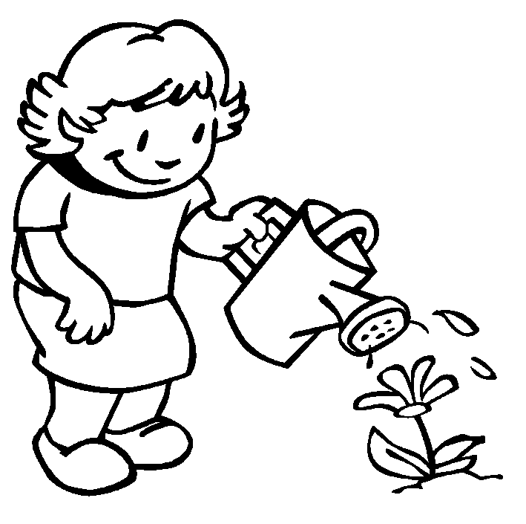
1. When a fruit or pod _________________, it breaks open.
2. Some seeds fall around the _________________ of the plant.
3. Birds eat the _________________ and drop the seeds.
4. Seeds can travel in ____________ until they stick to the shore.
5. Some seeds have _________________ on them that lets them float on the wind.
6. Others have wings that _________________ until they fall.
7. Some animals _________________ the seeds in the ground.
8. Some seeds hitchhike by _________________ to fur of animals.

Contractions Base Words

1. can’t _______ ________
2. he’s _______ ________
3. won’t _______ ________
4. Bob’ll _______ ________
5. they’re _______ ________
6. she has ______________
7. they will ______________
8. I am ______________
9. let us ______________
10. here is ______________
1. beautiful _______________
2. ripening _______________
3. unsatisfied ______________
4. protected ______________
5. exciting _______________
6. unhappily _______________
7 carefully _______________
8. beginning _______________
9. unusually _________________
10. unfriendly __________________

Name ________________________________ From Seed to Plant 4
nutrition oak petal zinnias ripens streams beautiful protect
- Fruit trees grow well near ________________.
- Apples and oranges are full of ________________.
- Bananas are sweeter after they have ________________.
- Many fruits are ________________ with bright pretty colors.
- The fruit’s job is to _______________ the seeds.
- Acorns are grown on ________________ trees.
- ________________ are my mom’s favorite flower.
- The ________________ on the flower turned brown.
Match to make compound words. |  | Syllables 1, 2, 3, 4
1. sea___________________ | mill |  | 1.thumb | _____
2. sea___________________ | print |  | 2.advent | _____
3. sea___________________ | horse |  | 3.cradleboard | _____
4. butter_________________ | milk |  | 4.tornado | _____
5. butter_________________ | star |  | 5.information | _____
6. news___________________ | cup |  | 6.camera | _____
7. news___________________ | cast |  | 7.blanket | _____
8. news___________________ | sock |  | 8.understand | _____
9. wind___________________ | weed |  | 9. medicinal | _____
10. wind__________________ | paper |  | 10. pollination | _____

Name ________________________________________ From Seed to Plant 5
there their they’re two too to
- ________________ were five insects in the flower bed.
- The children went ________________ the park to play ball.
- The boys left ________________ soccer ball in the rain.
- ________________ flying to Atlanta for the first time.
- _____________ is ____________ much noise in the classroom.
- He bought ________________ new pencils and some erasers.
- Why are ________________ toys scatted all over the floor?
- My dog protects the yard and the house, ________________.
Write the contractions: |  | Match the vowel sounds
- you will | ___________ | - slope | _____________ | view
- we are | ___________ | - troop | _____________ | joint
- will not | ___________ | - grip | _____________ | sneeze
- it is | ___________ | - mule | _____________ | glow
- do not | ___________ | - deal | _____________ | cast
- have not | ___________ | - camp | _____________ | hood
- I am | ___________ | - trot | _____________ | him
- he has | ___________ | - soil | _____________ | crop
- mom had | ___________ | - cook | _____________ | loose

- protects  - beautiful  - different  - food  - streams  - light  - nutrition  - air  - ripens  - water | - stigma  - contains  - insects  - nectar  - stamen  - pistil  - pollen  - hummingbirds  - pollination  - ripening | - clothes  - around  - pollinate  - pod  - ground  - protect  - shore  - scatters  - acorns  - parachutes | - envelopes  - directions  - explain  - vegetables  - curled  - sprout  - germination  - minerals  - vitamins  - garden

