Name __________________________HC 2-1 Get Up and Go

Sounds L S
- heel_________
- huge ________
- true ______
- bus _____
- can _____
Quiz:
- _______________________
- _______________________
- _______________________
- _______________________
- _______________________

- make_________
- ride _________
- jump ________

- frog ________
- wish ______

- _______________________
- _______________________
- _______________________
- _______________________
- _____________________

Use your Glossary. Match the meaning to the word.
1. always ______ a. hug and cuddle
2. homework ______ b. all the time
3. minutes ______ c. schoolwork that is done in the home
5. treat ______ d. units of time;
4. snuggle ______ e. a special gift

Name _______________________ Date _____________ HC 2-1

Sounds: L S
- big________
- not________
- been_______
- five_______
- ask_______
Quiz:
- _______________________
- _______________________
- _______________________
- _______________________
- _______________________
Get Up and Go
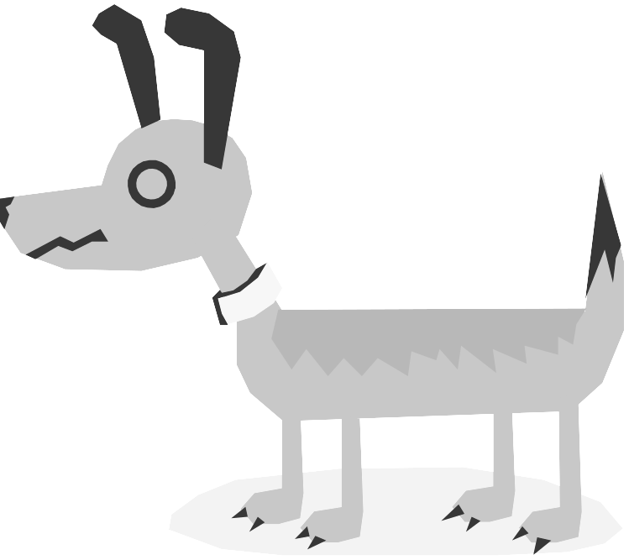
- had _______
- wish_______
- stand_______
- kind_______
- ate _______

- ______________________
- ______________________
- ______________________
- ______________________
- _____________________

Use your Glossary. Match the meaning with the word.
treat homework minutes always snuggle
- ________________________ tells about time.
- ___________________________ means to hung and cuddle.
- ___________________ means something happens all the time.
- A ____________________________ is a special gift.
- __________________________ is schoolwork we do at home.

Name ________________________ Date _____________ 2-1

Sounds: L S
- quite _____
- light _____
- kick________
- shine _______
- hid _______
Quiz:
- _______________________
- _______________________
- _______________________
- ______________________
- ______________________

Get Up and Go
- have______
- find_______
- flute________
- take_______
- let_______

- ______________________
- ______________________
- ______________________
- ______________________
- _____________________

Use these words: treat homework minutes always snuggle
- There are 60 ________________________ in an hour.
- She is ________________________ the last to go.
- We don’t have ________________________ on the weekend.
- My dog get a __________________________ every night.
- My cat likes to _________________________ next to me.

Name __________________ Date _____________2-1

Sounds L S
1. cold _________
- use_________
- been_________
- cub__________
- when_________
Quiz:
- ______________________
- _____________________
- ______________________
- ______________________
- ______________________

Get Up and Go
- fly _________
- may _______
- fish__________
- best__________
- must_________

- _____________________
- ______________________
- ______________________
- _____________________
- _____________________

Use these words: treat homework minutes always snuggle

- ______________________ It is a compound word.
- ______________________ The s on the end means more than one.
- ______________________ It has a short u sound.
- ______________________It has a long e sound.
- _____________________ It is the opposite of never.

Name __________________________ Date _____________ 2-1
Sounds: L S Get Up and Go

- swim______
- kite_______
- fork_______
- and________
- red________
Quiz
1. ____________________
2. _____________________
3. _____________________
4. ______________________
5. ______________________

- frog_______
- smart_______
- duck_______
- nose_______
- place ______

6. _____________________
7. ______________________
8. ______________________
9. ______________________
10. _____________________

treat homework minutes always snuggle
- __________________________ It means all the time.
- ___________________ This is school work that is done at home.
- It takes sixty second to make a _______________________.
- _____________________ It is when you hug and cuddle.
- _____________ This can be a special gift or a type of snack.

