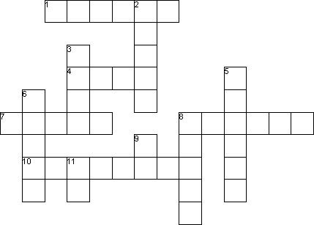
Name _________________________________ Spelling Practice- Hedgehog
court
Dr.
fourth
mourn
open
poured
resource
smell
source
St.
thank
your

Write the word in the blank:
Across
1. My team has won for the __________________ year in a row.
4. If the store is ________________________, we can by some milk.
7. The team ran toward the basketball _________________________.
8. The water _____________________ in the local pond.
10. Oil is an important natural _____________________.
Down
2. You should _________________________ your friends for helping out.
3. _____________________________ story was very interesting.
5. My mom _____________________________ the milk into the glass.
6. I will ________________________ when my vacation is over.
8. Fred loves the __________________________ of fresh, hot cookies.
9. ______________ Jones gave her medicine when she was sick.
11. Ellen lives on Main _______________ in Pembroke.

ord

