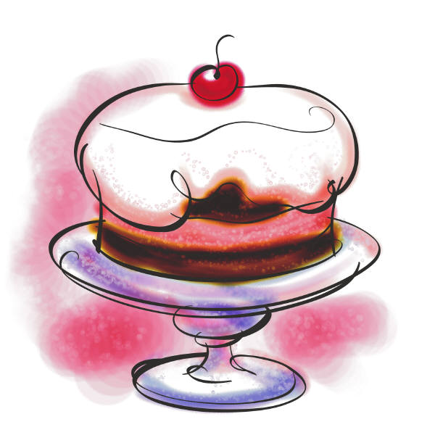
Name ________________________ Date __________________________
Hedgehog Bakes a Cake - Study Guide
Vocabulary
batter buttery perfect
recipe smeared yellow cake
1. It is the __________________day to walk in the woods.
2. We baked a ______________________ for the party.
3. My hands are ___________________________from the toast.
4. Following a ____________________is like following directions.
5. Dad poured the cake ____________________ in the pan.
6. We _______________________butter on the bread.
Comprehension
7. This is not a true story because ________________________
8. What is the setting of this story? ________________________
9. Who is the main character is this story? ____________________
10. How does Rabbit make a cake? ________________________
____________________________________________
11. Rabbit says someone is calling him because __________________________________________
12. Hedgehog wants to turn down Owl’s help because __________________________________________
__________________________________________
13. Why does Hedgehog let Owl help?
________________________
14. What does Squirrel think will happen after the cake is baked? ___________________________________________
15. What is the only thing Hedgehog uses in his second cake that he used in his first cake? ____________________________________
16. Hedgehog‘s friends know that the cake is done because they ___________________________________________
17. How many slices of cake does each friend eat? _________________
18. What does Hedgehog say to his friends so they will not help him bake anymore? _____________________________________
19. Why does Hedgehog lock his kitchen door? ___________________________________________
_____________________________________________
20. Explain the steps Hedgehog takes to make a cake?
__________________________________________
____________________________________________________________________________________________________________________________________________________________________________________

