Name _________________________________ J. Appleseed 1
peer smear fear deer cheerleaders gear dearly

1. Johnny did not carry much camping _________________ with him.
2. He didn’t _________________ any of the wild animals.
3. The _________________ roamed freely on the frontier.
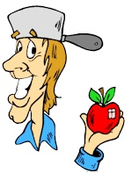
4. Did anyone ever _________________ in the pot he wore on his head.
5. I love my parents and my family _________________
6. The _________________ were so tired after the game.

Base words  easy | Add s, es, ies, ves  brushes
- easily __________________  - stolen __________________  - unopened _______________  - returned ________________  - smiling __________________  - babies __________________  - skipped __________________  - boxes __________________  - unexpected _______________ | - bush __________________  - cherry __________________  - toy __________________  - calf _________________  - match __________________  - daisy __________________  - fox __________________  - lady __________________  - knife __________________

Name _________________________________ J. Appleseed 2
yawned careful friends neighbors truth stretched startled

1. They were _______________ by the pioneers.
2. The Indians were going to be their _______________.
3. Johnny was so tired ______________ and _______________.
4. We are going to be good _______________.
5. Tree Planter always speak the _______________.
6. Be very _______________ of she-bear.

she we us them  there he it  she | Match: shook gather proof smart sound pot ripped bones song road  road
1. Mrs. Smith __________  2. Mom and I __________  3. some skates __________  4. Dad and me __________  5. a green door __________  6. Uncle Sam __________  7. on the porch __________  8. the children and me ______  9. the skates __________ | - street 1.______________  - skeleton 2.______________  - collect 3. _____________  - tore 4. _____________  - evidence 5._____________  - tune 6.______________  - clever 7._____________  - noise 8._____________  9. pan 9. _____________

Name _________________________________ J. Appleseed 3

We’re we’d didn’t won’t you’d weren’t haven’t
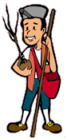
1. They_________________ going to give up their dreams.
2. They said _______________ better go with them now.
3. When did you say _______________ have to leave.
4. There ______________been any Indians around here today.
5. Why _______________the boys come home before dark?
6. _______________ going to be pioneers for a week.
7. The boy _____________________ do his homework.
Compound Words- MATCH: ball ware out train base straw hard brief berries rattle class doors snake case mate wagon | ABC ORDER  never stripe drape drain dreary strap nothing neater
base  1. ______________________  2. ______________________  3. ______________________  4. ______________________  5. ______________________  6. ______________________  7. ______________________  8. ______________________ | - ____________________  - ____________________  - ____________________  - ____________________  - ____________________  - ____________________  - ____________________  - ______________________

Name _________________________________ J. Appleseed 4
nearby survive wild cobblers orchards alarm tame frontier

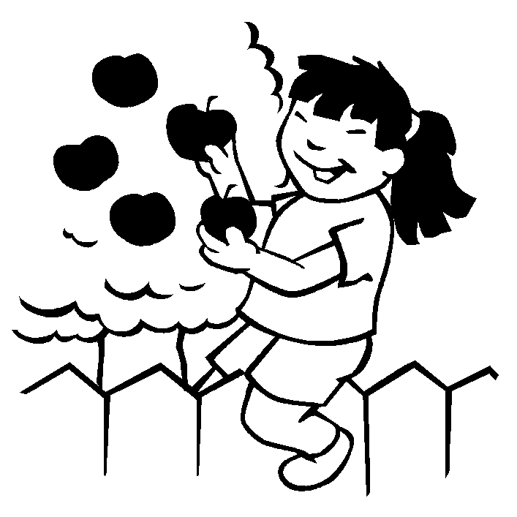
- People moved to the __________________ to get new land.
- You should not try to pet a __________________ animal.
- Mom stayed __________________ to watch us swim.
- Desert animals can __________________ without much water.
- Some farmers plant peach __________________.
- It is not a good idea to try and __________________ a wild animal.
- People take their shoes to the _______________ to be fixed.
Opposites | Match : vowel sound
f  1. finish____ a. short  2. away _____ b. last  3. sun _____ c. close  4. asked_____ d. tote  5. carry____ e. told  6. long_____ f. start  7. first___ g. different  8. same ____ h. moon  9. shut ___ i. toward | now  1. cow ____________  2. fat ___________  3. feet ____________  4. hike ____________  5. loud ____________  6. bird ____________  7. jump ____________  8. cake _____________  9. noise_____________ | same  jeep  boy  clown  now  shut  flat  ride  turn

Name _________________________________ J. Appleseed 5
fifty earth frontier thousands pioneers survive animals sky mother
- What was Johnny Appleseed’s real name? ____________ __________
- The people that moved out west were called ______________________ .
3. He liked ______________________ as much as people.
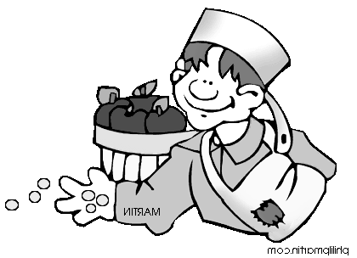
4. Johnny said the _________________ was his floor and the sky was his _____________________ .
5. The Indians taught Johnny to _________________.
6. The she-bear was a _____________________ bear.
7. Johnny said he thought he had walked a ___________________ of miles.
8. How long did it take to plant all those apple trees? _________________
9. What does it mean to have “itchy feet”? _________________________
__________________________________________________________

C if it is a compound word  X if not |  | their there they’re
1. windbreaker | _____ | 1. I left my books over ____________________.
2. farmhouse | _____ | 2. ___________________ are three people here.
3. shortened | _____ | 3. We went to ______________ house for a picnic.
4. cornmeal | _____ | 4. ____________________ pigs ate our garden.
5. shipment | _____ | 5. ___________________ cleaning out the attic.
6. colorful | _____ | 6. Did you see _________________ new puppy?
7. rattlesnake | _____ | 7. ____________________ taking him to the vet.
8. peaceful | _____ | 8. Will you go ____________________ with him?
9. appleseed | _____ | 9. ______________ having fun with the new puppy.

