
Name ________________________________“Johnny Appleseed”
Grammar Test – Skill Reminder:
- The names of days of the week are proper nouns.
- The names of days begin with a capital letter.

Directions: Write each proper noun correctly.

- mr john chapman __________________________________________

- wednesday _____________________________________________
- chicago, illinois __________________________________________

- Tuesday ________________________________________________
- apple tree lane __________________________________________

- saturday ______________________________________________

- pennsylvania __________________________________________
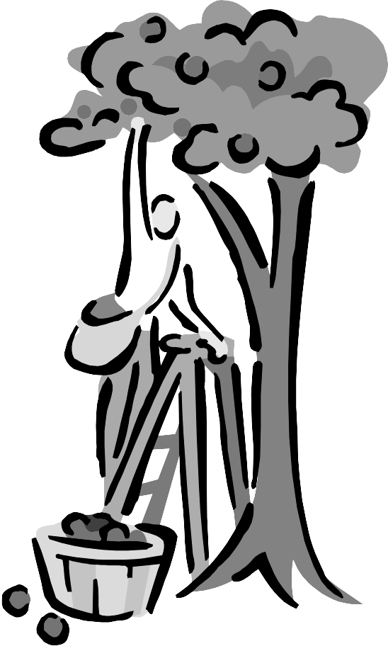

Directions: Re-write each sentence correctly

- johnny appleseed walked here. __________________________________

___________________________________________________________

- He walked every day except sunday. ________________________________

_____________________________________________________________

10. mr appleseed’s feet must have hurt on saturdays! ____________________

___________________________________________________________

