1  Page 286  GPS:  Focus: What is the genre? How is this different from other stories?  Respond:  _______________________________________________________________________________________________________________________________________________________________________________________________________________________________________________________  ELA2R4m Recognizes elements of the genre | 2  Page 290-291  GPS:  Focus: Do you think Johnny has brought everything he will need? Tell why.  Respond:  _______________________________________________________________________________________________________________________________________________________________________________________________________________________________________________________  ELA2R4b Make  predictions from text | 3  Page 294-295  GPS:  Focus: Does Johnny really have a cabin? Explain your answer.  Respond:  _______________________________________________________________________________________________________________________________________________________________________________________________________________________________________________________  ELA2R4i Identifies & infers main idea & details
4  Page 298-299  GPS:  Focus: Why doesn’t Johnny sleep in the log?  Respond:  _______________________________________________________________________________________________________________________________________________________________________________________________________________________________________________________  ELA2R4k Identifies & infers cause & effect | ?  Page 300-301  GPS:  Focus: What does Johnny mean when he says he has planted too many trees to count? Explain.  Respond:  _______________________________________________________________________________________________________________________________________________________________________________________________________________________________________________________  ELA2R3d Determines meaning on basis of content | Johnny Appleseed  by:  Pleasant deSpain  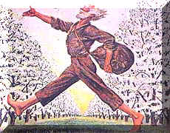  Name:_______________  Date:_________

