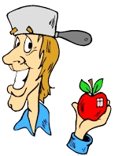
Name ______________________________ Johnny Appleseed

Study Guide
Write the correct word in the blank.
frontier nearby orchards survive tame wild
- There are apple _______________________ near our house.
- Can you __________________________ a lion?
- They moved west to the ______________________ lands.
- Many ________________________ animals live in the woods.
- We can walk to the park because it is _____________________.
6. On the frontier, it was sometimes hard to __________________.
After you have read the story, answer these questions.
- What genre is this story? _______________________________________
- Which character in the play fills in the details?_______________________
- Johnny Appleseed has ________ half-brothers and ______ half-sisters. (How many in all ? ______+______=________ )
- When does the play take place? ___________________________________
- What is Johnny Appleseed’s real name? _____________________________
_____________________________________________________________
- Where are Johnny’s neighbors moving in Scene One? __________________ _____________________________________________________________
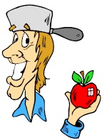
Name ___________________________________
- Settlers can’t take their apple trees to the west, so Johnny ____________ ___________________________________________________________
- How do the frontier children feel when they first see Johnny?
____________________________________________________________
- When he says, “I’ve got itchy feet,” what does Johnny mean?
______________________________________________________________
- How do Young Wolf and Ten Horses feel about Johnny?
______________________________________________________________
- How many years does Johnny travel and plant trees? _________________
- How are Pennsylvania, Ohio, and Indiana different because of Johnny?
__________________________________________________________

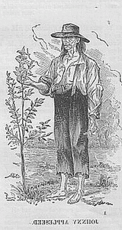
- Why did people give Johnny his two nicknames – Johnny Appleseed and Tree Planter? _____________________________________________________________
- List two foods that you can make with apples.
_______________________________________________________________

