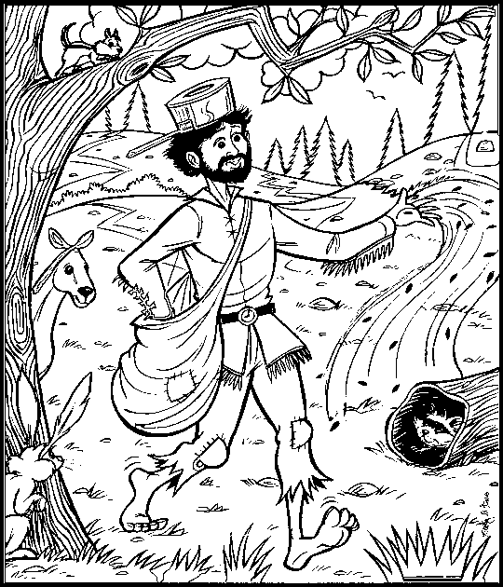
Name _______________________________________________________ Johnny Appleseed Picture Search
Directions:
Find the hidden pictures in the picture of Johnny Appleseed. Then color the pictures you find with your pencil.

