Name __________________________Date__________ Johnny Appleseed 1
Sounds: L S R DPT VD |  | Teach and Test
1. shout______  2. neck______  3. boom_______  4. yard_______  5. those_______ | 6. rake____  7. swoop ______  8. herd______  9. told_______  10. soy_______ | 1.______________________  2.______________________  3.______________________  4.______________________  5.______________________
6.______________________  7.______________________  8.______________________ |  | 9.______________________  10.______________________
A. nearby B.survive C.frontier D.tame E. orchards F. wild
- ____ the part of the country at the edge of a settled area
- ___ not far away
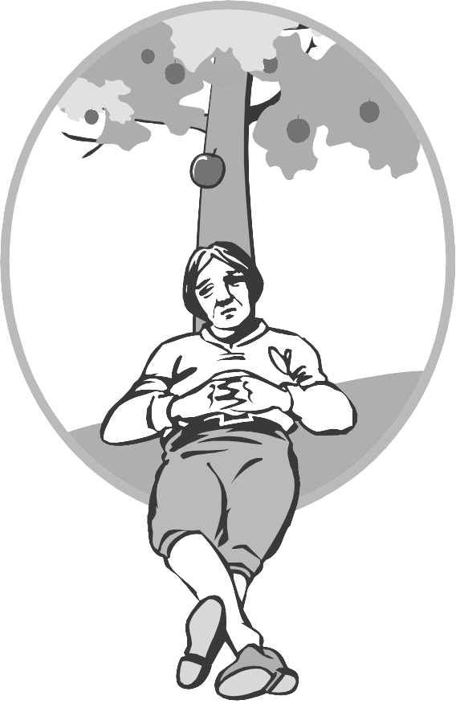
- _____ areas of land where fruit trees are grown
- ____ stay alive
- ____ to bring under control or make more gentle
- ____ in a natural state; not controlled by humans

1. i asked dr wang to gimme a teethbrush

_____________________________
2. my friend finded my pet snake named squiggy

____________________________

Name __________________________Date___________ Johnny Appleseed 2
Sounds: L S R DPT VD |  | Teach and Test
1. hound _______  2. bloom________  3.snow________  4. edge________  5. first ________ | 6. clue_______  7. milk________  8. groom_______  9. clown _______  10. curve_______ | 1.___________________________  2.___________________________  3.___________________________  4.___________________________  5.___________________________
6.______________________  7.______________________  8.______________________ |  | 9.______________________  10.______________________
A.nearby B.survive C.wild D.orchards E.tame F.frontier
- __ What you must do in the wilderness?
- __ A word to describe a fierce lion.
- __ What word is the opposite of faraway?
- __ A group of the same kind of trees grown for their fruit.
- __ Something that has not been explored.
- __ A word that is used to describe pets such as dogs or cats.
- we aint watching tv when hes here

_____________________________
2. do i haveta eat my butter beens
____________________________

Name __________________________Date___________ Johnny Appleseed 3
Sounds: L S R DPT VD |  | Teach and Test
1. shirt _______  2. pouch _____  3. booth_______  4. kick _______  5. turn________ | 6. broil______  7. hope_______  8. shoot ______  9. have_______  10. bird _____ | 1.___________________________  2.___________________________  3.___________________________  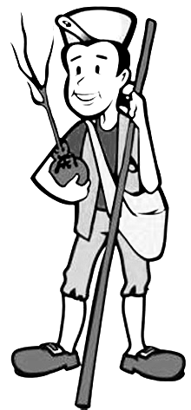  4.___________________________  5.___________________________
6.______________________  7.______________________  8.______________________ |  | 9.______________________  10.______________________
Wild survive frontier orchards tame nearby
- People moved to the __________________ to get new land.
- You should not try to pet a __________________ animal.
- Mom stayed __________________ to watch us swim.
- Desert animals can __________________ without much water.
- Some farmers plant peach __________________.
- It is not a good idea to try and __________________ a wild animal.
- me and lisa hided in the closet
_____________________________
2. we aint gonna go to the parade in december
____________________________

Name __________________________Date___________ Johnny Appleseed 4
Sounds: L S R DPT VD |  | Teach and Test
1. spoon________  2. worms________  3. feel________  4. scout _______  5. ghost________ | 6. plow ________  7. boat_______  8. crook_______  9. three______  10. card ________ | 1.___________________________  2.___________________________  3.___________________________  4.___________________________  5.___________________________
6.______________________  7.______________________  8.______________________ |  | 9.______________________  10.______________________
tame nearby survive orchards either wild frontier
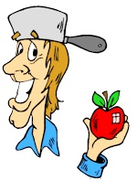
- The __________________ is a place where few people live.
- It is hard to __________________ in the desert.
- The fence will keep the __________________ animals out.
- We can get water at the __________________ river.
- Have you seen the orange __________________ in Florida.
- If we __________________ the deer, they will be like pets.

1. me and ken rided the bus
_____________________________
2. them boys wont share with us
____________________________

Name __________________________Date___________ Johnny Appleseed 5
Sounds: L S R DPT VD |  | Teach and Test
1. tight______  2. joys________  3. hard________  4. root________  5. show________ | 6. much_________  7. round________  8. smart________  9. broom________  10. play________ | 11.___________________________  12.___________________________  13.___________________________  14.___________________________  15.___________________________
6.______________________  7.______________________  8._____________________ |  | 9.______________________  10.______________________
nearby wild tame | survive frontier orchards
- These words are opposites: _________________ _________________  - The opposite of faraway is ____________________. | - Groups of apples, orange, or pecan trees: __________________  - The opposite of die is ____________________.  - This word rhymes with Lanier. ________________

- doesnt cathys hermit crab move fast
_____________________________
2. they was in dallas texas
____________________________

