Name _________________________ Lemonade for Sale 1
Find the misspelled noun in each sentence, circle it, and correct the spelling.
1. The little boy put his shoes on the wrong foots. ____________
2. Seven gooses flew over the lake. _________________
3. All the childs were invited to the party. _________________
4. It took many mans to fix the dock. _________________
5. We have twenty baby tooths. _________________
6. I like the song “The Three Blind Mouses”. _________________
7. There are seven bus in front of the school. __________________
8. Some of the puppy got out of the pen. ____________________

add: es ies s
- brush
- penny
- hat
- church
- book
- bunny
- glass
- lady
- fox

1. ___________________
2___________________
3. ___________________
4. ___________________
5. ___________________
6 ___________________
7. ___________________
8. ___________________
9. ___________________
Root Words

1. cried ______________
2. drying ______________
3. maddest ______________
4. dropping ______________
5. silliest ______________
6. hiding ______________
7. nicest ______________
8. arrived ______________
9. elves ______________

Name _____________________________ Lemonade for Sale 2

glum members events realistic arrived announced rebuild
1. The __________________ of the club have to learn to swim.
2. What __________________ do you want to do on field day.
3. The teacher saw the __________________ look on the children’s faces.
4. The man __________________ that the winner was number thirty-six.
5. The children __________________ just in time to see the magic show.
6. We need to __________________ the bridge after the water washed it away.

7. My book is more of a __________________ fiction than Sally’s fairly tale book.

S - Same
O - Opposite
- look - see _____
- play – work _____
- dry – wet _____
- afraid – scared _____
- dish – bowl _____
- hot – cold _____
- pull - push _____
- add – subtract _____
- sea – ocean _____
- sun – planet ____
Write the contraction: not= n’t, are=‘re, is or us = ‘s, have= ‘ve am = ‘m would =‘d, will =‘ll,
- is not - _______________
- will not _______________
- your are _______________
- that will _______________
- has not _______________
- I am _______________
- she will ______________
- they have _______________
- we would _______________

Name ______________________________ Lemonade for Sale 3
chattered bottom halfway couple shouted hardly bragged enough

- There is _____________ enough seeds for all these birds.
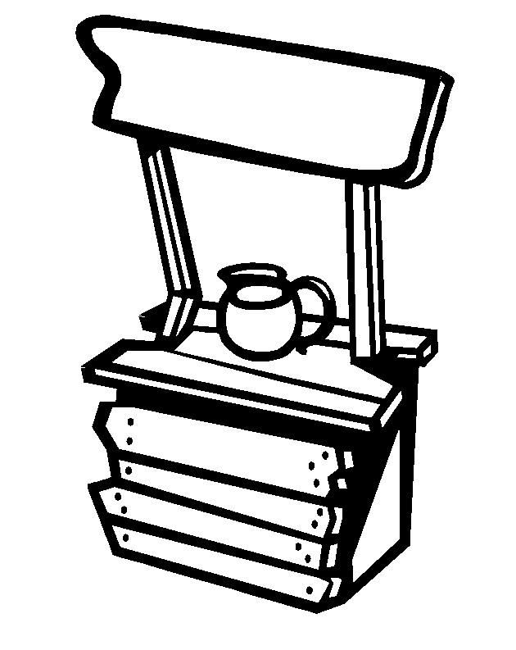
- He stood on the _____________ step to reach the window.
- The squirrels were _____________ in the trees.
- The lost boys _____________ for help.
- We went _____________ up the hill and slid back down.
- The boy _____________ that he won the race.
- The girls saw a _____________ of deer beside the road.
- Are there _____________ books for all the children?

Match words that mean the same.
come
heap
leave
sheet
shout
shut
tale
tote
under
unlock

- call _________________
- arrive ________________
- page________________
- carry ________________
- story ________________
- below________________
- close ________________
- open ________________
- go ________________
- pile ________________
Using pronouns- he, she, it they, us, we, them, there, his, her

- Anthony’s cat ___________
- at my school___________
- Uncle Jack ___________
- Hailey and I ___________
- Landon and me __________
- Grandmother __________
- Gavin and Jamie _________
- Alexus’ dog _________
- the squirrel ___________
- the skates __________

Name ______________________________ Lemonade for Sale
Monday sugar week squawked squeezed shook clubhouse
day piggybank Matthew bar graph

- The __________________ was falling down and the __________________ was empty.
- __________________ said, “Let’s sell lemonade.”
- They wanted to sell 30 or 40 cups every _________ for a______________.
- Sheri decide to make a__________________.
- On __________________ they set up their corner stand.
- Petey __________________ “Lemonade for sale!”
- Matthew __________________ lemon and Meg mixed in some__________________, and Danny __________________ it up with ice.
adult
always
destroy
dog
front
give
last
question
silent
stay
stay

Opposites
- child _________________
- first _________________
- move _________________
- get________________ __
- sound _________________
- make _________________
- answer_________________
- back _________________
- never_________________
- puppy ________________

Words that go together:
peas, pen, hail, bananas, eyes,
red, duck, chair, bush

- blue gold _______________
- bed table _______________
- rain snow _______________
- grapes, apples, ____________
- goose chicken _____________
- flower tree _______________
- nose face _______________
- pencil paper ______________
- carrot, peppers, ___________

Name ______________________________ Lemonade for Sale 5
graph up great down neighborhood track

- Sheri kept __________________ of how many cups were sold.
- How many cups did they sell on Monday? _________________
- How many cups did they sell on Tuesday? _________________
- The bars ____________ show that their sales are going__________.
- On Wednesday most of the __________________ stopped by.
- They sold ________ cups on Wednesday.
- Everyone said they were doing __________________.
- On Thursday they sold ______ cups and the bar graph went _____________.

Verb in the past
Today I Yesterday I
- shake ______________
- hurry _____________
- swim ______________
- make ______________
- come ______________
- walk ______________
- give _____________
- eat ______________
- jump ______________
X the one that doesn’t go with the others.
- knock | whistle | rap
- car | ship | bicycle
- plate | saucer | glass
- thirty | sixty | inches
- grin | moan | groan
- trot | chatter | gallop
- dentist | sheriff | police
- apples | corn | peas
- John | they | she

