Name ________________Date_______________ “Montique” 1
Sounds: L S R DPT VD Match Vowel Sounds by letters

1. shout______
2. neck______
3. boom_______
4. yard_______
5. those_______
Quiz:
1.______________________
2.______________________
3.______________________
4.______________________
5.______________________

6. bean_______
- pause
- beach
- born
- first
- stuff
- fruit
7. worst______
8. clutch______
9. warm_______
10. lawm_______

6._______________________
7._______________________
8._______________________
9._______________________
10.____________________

a. cozy b. drifted c. fleet d. launched e. looming f. realized

1. ____ understood, figured out
2. ____ group of ships or boats
3. ____ snug, comfortable
4. ____ appearing large and scary
5. ____ pushed along by moving water
6. ____ caused to slide into the water
Name _______________________Date_________________ “Montique” 2
Sounds L S R VD DPT Divide into syllables

1. hound ________
2. bloom_________
3. stuck________
4. edge________
5. first _________
Quiz:
1.______________________
2.______________________
3.______________________
4.______________________
5.______________________

6. graduate__________________
7.rodeo_____________________
8. idea_____________________
9. pioneer____________________
10. create____________________

6._______________________
7._______________________
8._______________________
9._______________________
10.______________________

a. drifted b. cozy c. looming d. realized e. fleet f. launched
- Juan will be warm and _______ in his new jacket.
- The tall trees were _______ above them.
- They had a _______ of paper boats.
- The boys _______ the boats by pushing them into the water.
- The boats _______ slowly with the breeze across the pond.
- They _______ it was time to go home.

Name ___________________Date______________ “Montique” 3
Sounds L S R VD DPT ROOT WORDS

1. shirt ________
2. pouch _________
3. booth_______
4. kick _______
5. turn________
Quiz:
1.______________________
2.______________________
3.______________________
4.______________________
5.______________________

6. repainted______________
7. unsafely________________
8. unhandy _______________
9. distasteful______________
10. displeased_____________

6._______________________
7._______________________
8._______________________
9._______________________
10.______________________

a. fleet b. looming c. cozy d. launched e. realized f. drifted

- _______ This word has two long vowel sounds.
- ____ ____ _____ These three words tell about the past.
- _______ This words has the same vowel sound as tool.
- _______ This word has the same vowel sound as steel.

Name _____________________Date___________ “Montique” 4

Sounds L S R VD DPT 1.when 2.where 3.how

1. spoon________
2. worms________
3. feel________
4. scout _______
5. ghost________
Quiz:
1.______________________
2.______________________
3.______________________
4.______________________
5.______________________

6. slowly ________
7. tomorrow_______
8. at the park_______
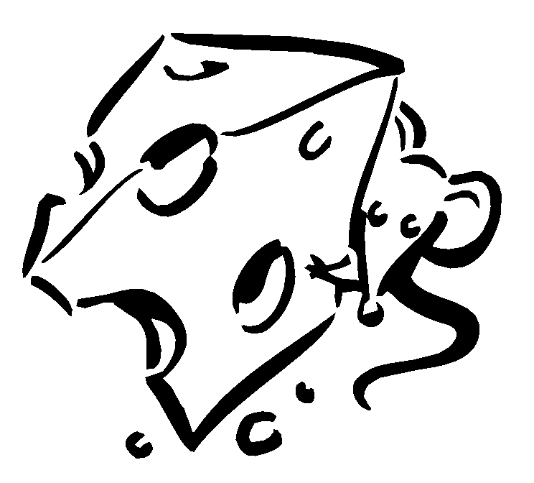
9. midnight______
10. happily_______

6._______________________
7._______________________
8._______________________
9._______________________
10.______________________

a. cozy b. drifted c. fleet d. launched e. looming f. realized
- Bill saw a large, dark figure _______ in the yard.
- It felt warm and _______ under the quilt.
- I watched the _______ sail out of the harbor.
- I finally _______ the loud noise was the rain on the roof.
- Suzie _______ the sailboat into the water.
- The piece of wood _______ along in the ocean.

Name _________________________ “Montique” 5

Sounds L S VD R DPT N =noun, P= pronoun, V=verb, A =adjective

1. tight________
2. loud_________
3. hard__________
4. jump________
5. show__________
Quiz:
1.______________________
2.______________________
3.______________________
4.______________________
5._____________________

6. them______
7. fat__________
8. smart________
9. palace_________
10. flew________

6._______________________
7._______________________
8._______________________
9._______________________
10.____________________

a.realized b. drifted c. fleet d. launched e. looming f. cozy

- The _______ of ships were headed for Hawaii.
- After the new ship was _______ , it the motor stopped.
- The new ship _______ in the ocean.
- The men were sleeping in their _______ beds.
- The alarm sounded because a storm _______ over the ocean.
- They _______ that they would need to call for help.

