Name __________________________________________ Spelling Homework
Word Box

August
before
blue
December
doctor
January
mister
mistress
rehearse
room
search
street
Sunday
Tuesday
Wednesday

Mr. Putter and Tabby Fly the Plane
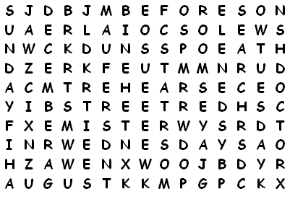

Write the abbreviation for the under line word.
- Mister Smith lives next door. _______________________
- Mistress Hodges is my teacher. _______________________
- Doctor Newman is the principal of the school. ____________
- January is the first month of the year. _________________
- We start school in August. _______________________
- Christmas comes in December. _______________________
- Wednesday is in the middle of the week. ________________
- We go to church on Sunday. _______________________
- He lives at 111 Main Street. _______________________
- We go to art on Tuesday. _______________________

