Name _______________________Date________ “Mr. Putter”
Sounds L S R

1. heard__R___
2. split__S___
3. sky__L___
4. slept__S___
5. rule __L___
Quiz:
1.______________________
2.______________________
3.______________________
4.______________________
5.______________________
Reading Words:
6. thirty__R___
7. rise___L__
8. load__L___
9. dust__S___
10. sack___S__

6._______________________
7._______________________
8._______________________
9._______________________
10.______________________

A. crane B. directions C. promise D. twitch E. worry
1. __D__to move with a sharp, quick movement

2. __A__machines with long, movable arms used to lift things

3. __E__to think that bad things may happen
4. __B__instructions on how to do something
5. __C__pledge or a statement make by a person telling that he or she will
do something

Name _______________________Date________“Mr. Putter”

Sounds L S R

1. aunts _S____
2. judge __S___
3. score __R___
4. pole __L___
5. broke ___L__
Quiz:
1.______________________
2.______________________
3.______________________
4.______________________
5.______________________

6. thick ___S__
7. shut __S___
8. blast __S___
9. curb __R___
10. pink ___S__

6._______________________
7._______________________
8._______________________
9._______________________
10._____________________

Reading Words: Match up words that mean the same. Write the number.
- buy | _4 think bad things | - crane | _8_ boat
- twitch | _1_pay money | - direction | _6_ huge machine
- huge | _2_ quick movement | - barge | _7_ instruction
- worry | _3_ex-large | - promise | _9_ pledge

Name ______________________Date_________“Mr. Putter”
Sounds L S R

1. worth __R__
6. hid __S__

2. pride _L___
3. sign __L__
4. rush __S__
5. clock __S__
Quiz:
1.______________________
2.______________________
3.______________________
4.______________________
5.______________________

7. light __L__
8. toast __L__
9. chart __R__
10. blind __L__

6._______________________
7._______________________
8._______________________
9._______________________
10.______________________

Reading Words worry cranes directions twitch promise
1. I read the directions to find out how it works.
2. I watch my dog’s nose wiggle and twitch
3. He made me promise I would be careful.
4. I tried not to worry about my dog.
5. The cranes can lift a steel beam.

Name _______________________Date_________“Mr. Putter”
Sounds: L S R

1. thumb _ S ___
2. prove __ S __
3. flea __ L __
4. yarn __ R __
5. splash __ S __
Quiz:
1.______________________
2.______________________
3.______________________
4.______________________
5.______________________

6. patch _ S ___
7. prove _ L ___
8. sight __ L __
9. chain __ L __
10. curl _ R ___

6._______________________
7._______________________
8._______________________
9._______________________
10.______________________

Reading Words: A. promise B. twitch C. directions D. crane E. worry
1. __ B __ What you might do if a fly lands on your nose.
2. __ A. __ You say you will do something without fail.

3. __ D __ It is a tall machine.
5. __ E __ When you think bad things will happen.
4. __ C __ It means instructions.

Name _______________________Date________“Mr. Putter”

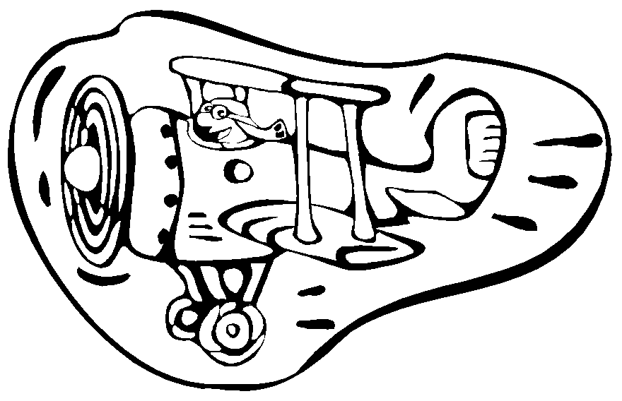
Sounds L S R

1. spend __ S __
6. tea _ L ___

2. lie __ L __
3. teeth __ L __
4. check ___ S _
5. burn __ R __
Quiz:
1.______________________
2.______________________
3.______________________
4.______________________
5.______________________

7. smart __ R __
8. sign __ L __
9. worn __ R __
10. tame __ L __

6._______________________
7._______________________
8._______________________
9._______________________
10._____________________

Reading Words: A. promised B. twitched C. directions D. crane E. worry
1. The man asked for __ C. __ to the farm.
2. We need a ___ D __ to unload the ship.
3. He will __ E __ if he loses his lunch money.
4. The groundhog B. his nose to smell for spring.
5. I __ A. __ my mom that I would go straight home after school

