Name _______________________Date________ “Mr. Putter”
Sounds L S R

1. heard _____
2. split_____
3. sky_____
4. slept_____
5. rule _____
Quiz:
1.______________________
2.______________________
3.______________________
4.______________________
5.______________________
Reading Words:
6. thirty_____
7. rise_____
8. load_____
9. dust_____
10. sack_____

6._______________________
7._______________________
8._______________________
9._______________________
10.______________________

A. crane B. directions C. promise D. twitch E. worry
1. ____to move with a sharp, quick movement

2. ____machines with long, movable arms used to lift things

3. ____to think that bad things may happen
4. ____instructions on how to do something
5. ____pledge or a statement make by a person telling that he or she will
do something


Name _______________________Date________“Mr. Putter”
Sounds L S R

1. aunts _____
2. judge _____
3. score _____
4. pole _____
5. broke _____
Quiz:
1.______________________
2.______________________
3.______________________
4.______________________
5.______________________

6. thick _____
7. shut _____
8. blast _____
9. curb _____
10. pink _____

6._______________________
7._______________________
8._______________________
9._______________________
10._____________________

Reading Words: Match up words that mean the same. Write the number.
- buy | __ think bad things | - crane | __ boat
- twitch | __pay money | - direction | __ huge machine
- huge | __ quick movement | - barge | __ instruction
- worry | __ex-large | - promise | __ pledge

Name ______________________Date_________“Mr. Putter”
Sounds L S R

1. worth ____
6. hid ____

2. pride ____
3. sign ____
4. rush ____
5. clock ____
Quiz:
1.______________________
2.______________________
3.______________________
4.______________________
5.______________________

7. light ____
8. toast ____
9. chart ____
10. blind ____

6._______________________
7._______________________
8._______________________
9._______________________
10.______________________

Reading Words worry directions cranes twitch promise
1. I read the _________________ to find out how it works.
2. I watch my dog’s nose wiggle and ____________________.
3. He made me _____________________ I would be careful.
4. I tried not to _______________________ about my dog.
5. The _________________________ can lift a steel beam.

Name _______________________Date_________“Mr. Putter”
Sounds: L S R

1. thumb ____
2. prove ____
3. flea ____
4. yarn ____
5. splash ____
Quiz:
1.______________________
2.______________________
3.______________________
4.______________________
5.______________________

6. patch ____
7. prove ____
8. sight ____
9. chain ____
10. curl ____

6._______________________
7._______________________
8._______________________
9._______________________
10.______________________

Reading Words: A. promise B. twitch C. directions D. crane E. worry
1. ____ What you might do if a fly lands on your nose.
2. ____ You say you will do something without fail.

3. ____ It is a tall machine.
5. ____ When you think bad things will happen.
4. ____ It means instructions.

Name _______________________Date________“Mr. Putter”

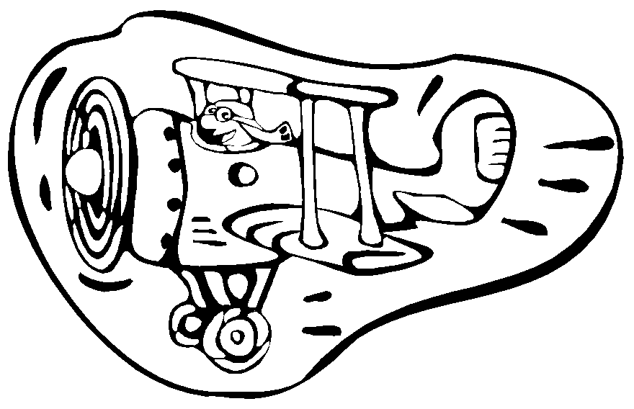
Sounds L S R

1. spend ____
6. tea ____

2. lie ____
3. teeth ____
4. check ____
5. burn ____
Quiz:
1.______________________
2.______________________
3.______________________
4.______________________
5.______________________

7. smart ____
8. sign ____
9. worn ____
10. tame ____

6._______________________
7._______________________
8._______________________
9._______________________
10._____________________

Reading Words: A. promised B. twitched C. directions D. crane E. worry
1. The man asked for ____ to the farm.
2. We need a _____ to unload the ship.
3. He will ____ if he loses his lunch money.
4. The groundhog _____ his nose to smell for spring.
5. I ____ my mom that I would go straight home after school

