Name ____________________________________________ Word Box
Seed Plant Orange pumpkin Flower Green pumpkin Sprout

Color the Pumpkin Correctly !!!

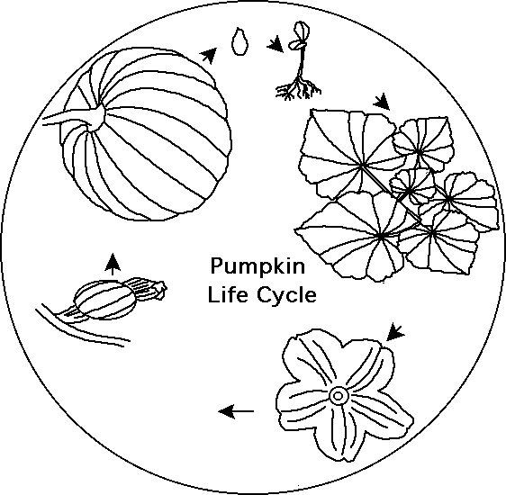
Color box Orange for Old Juana
Color box Green for Fernando

____Picked insects of the vines  ____Splashed a few drops of ____water  ____Broke up the clods of soil  ____Grew scrawny vines  ____Planted three seeds to a mound  ____Gave each plant a cool drink | ____Scattered seeds in every directions ____Hoeing the plot of land  ____Grew strong vines  ____Pumpkins were small, shriveled, and green  ____Pumpkins were the color of the harvest moon  ____Forgot to water the plants

