Name ______________________________________________ Study Guide

The Secret Life of Trees

Write the correct word in the blank.
discover energy forecast shed source
1. When did they _____________________ the surprise?

2. We need ____________________________ to run the long race.

3. Some trees ____________________ their leaves in autumn.

4. The sun is a good ________________________ of light.

5. There is a ____________________________ of rain today.

1. What is the genre of this selection? ______________________
2. Why is The Secret Life of Trees a good title for this book?
____________________________________________________
____________________________________________________
3. According to this selection, what is the heaviest thing on Earth?
_____________________________________________________
4. The tree’s bark protects the _____________________________
_____________________________________________________
5. A tree gets its food from the ____________________________
6. Can a tree live without sun and water? ____________________
7. Can a tree live longer than other living things? ______________
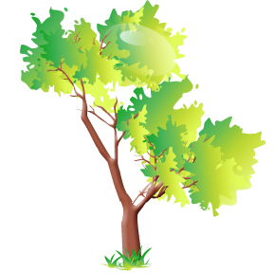
8. Which kinds of trees lose their leaves in winter? _____________
_____________________________________________________
9. Seeds may never grow into a tree because __________________
_____________________________________________________
10. How long is the sugar pine cone? ________________________
11. Pine cones forecast a storm by __________________________
_____________________________________________________
12. The tallest tree alive today is growing in __________________
13. Name two things that are made from wood: __________________
_____________________________________________________
14. Why are the branches of conifers bouncy? _______________
_____________________________________________________
15. Why can a palm tree’s seed grow without water? ___________
_____________________________________________________
_____________________________________________________
_____________________________________________________
16. What does the author mean by “in summer a tree is an animal hotel”? ____________________________________________________
_____________________________________________________
_____________________________________________________
_____________________________________________________

