1  Page 282  GPS:  Focus: What is the genre of this story? Tell what to look for in that genre.  Respond:  _______________________________________________________________________________________________________________________________________________________________________________________________________________________________________________________  ELA2R4m Recognizes elements of the genre | 2  Page 284-285  GPS:  Focus: Who is telling the story? Tell how you know.  Respond:  _______________________________________________________________________________________________________________________________________________________________________________________________________________________________________________________  ELA2R4j l Self-monitors comprehension, Recognizes characters | 3  Page 288-289  GPS:  Focus: Whys does Rosalba want to fly where the ships are docked?  Respond:  _______________________________________________________________________________________________________________________________________________________________________________________________________________________________________________________  ELA2R4d Recalls explicit & infers implicit facts
4  Page 296-297  GPS:  Focus: Where do you think Rosalba and Abuela will go next?  Respond:  _______________________________________________________________________________________________________________________________________________________________________________________________________________________________________________________  ELA2R4b Make  predictions from text | ?  Page 298  GPS:  Focus: Why did the author write this story? Explain your answer.  Respond:  _______________________________________________________________________________________________________________________________________________________________________________________________________________________________________________________  ELA2R4o Determines author’s purpose | Abuela  by:  Arthur Durros  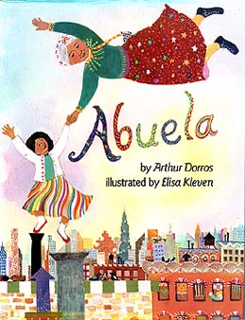  Name:_______________  Date:_________

