1  Page 230-231  GPS:  Focus: What is the genre? How is this different from other stories?  Respond:  _______________________________________________________________________________________________________________________________________________________________________________________________________________________________________________________  ELA2R4m Recognizes elements of the genre | 2  Page 234-235  GPS:  Focus: Tell what has happened so far in the story.  Respond:  _______________________________________________________________________________________________________________________________________________________________________________________________________________________________________________________  ELA2R4e Summarize text content | 3  Page 240-241  GPS:  Focus: What have you learned so far about Anthony?  Respond:  _______________________________________________________________________________________________________________________________________________________________________________________________________________________________________________________  ELA2R4e Summarize text content
4  Page 242-243  GPS:  Focus: What does the saying, “passing of the rope” mean?  Respond:  _______________________________________________________________________________________________________________________________________________________________________________________________________________________________________________________  ELA2R3d Determines meaning on basis of content | ?  Page 244-245  GPS:  Focus: Why do you think the author wrote this story? Tell why.  Respond:  _______________________________________________________________________________________________________________________________________________________________________________________________________________________________________________________  ELA2R4o Recognize author’s purpose | Anthony Reynoso  Born to Rope  by:  Martha Cooper & Ginger Gordon  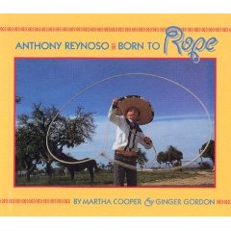  Name:_______________  Date:_________

