1  Page 124-125  GPS:  Focus: What is the genre? How is this different from other stories?  Respond:  _______________________________________________________________________________________________________________________________________________________________________________________________________________________________________________________  ELA2R4m Recognizes elements of the genre | 2  Page 130-131  GPS:  Focus: What other animal eats shrimp like creatures?  Respond:  _______________________________________________________________________________________________________________________________________________________________________________________________________________________________________________________  ELA2R4h Make connections between texts | 3  Page 132-133  GPS:  Focus: How would you feel if you stood around for 2 months without food? Explain your answer.  Respond:  _______________________________________________________________________________________________________________________________________________________________________________________________________________________________________________________  ELA2R4h Make connections between texts
4  Page 140-141  GPS:  Focus: Why doesn’t the father take the baby to the sea to get food?  Respond:  _______________________________________________________________________________________________________________________________________________________________________________________________________________________________________________________  ELA2R4i Identifies & infers main idea & details | ?  Page 144-145  GPS:  Focus: Would you rather be a male or female penguin? Explain your answer.  Respond:  _______________________________________________________________________________________________________________________________________________________________________________________________________________________________________________________  ELA2R4h Make connections to personal experiences | The Emperor’s Egg  by:  Martin Jenkins  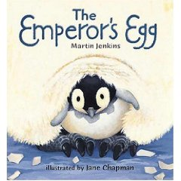  Name:_______________  Date:_________

