1  Page 230-231  GPS:  Focus: What does Hedgehog do before he hears a knock at the door?  Respond:  _______________________________________________________________________________________________________________________________________________________________________________________________________________________________________________________  ELA2R4i Identifies main idea and details | 2  Page 234-235  GPS:  Focus: How do you think this cake will turn out? Tell why.  Respond:  _______________________________________________________________________________________________________________________________________________________________________________________________________________________________________________________  ELA2R4b Make  predictions from text | 3  Page 238-239  GPS:  Focus: Why does Hedgehog let Owl help?  Respond:  _______________________________________________________________________________________________________________________________________________________________________________________________________________________________________________________  ELA2R4i Identifies main idea and details
4  Page 240-241  GPS:  Focus: Why does Hedgehog lock the door?  Respond:  _______________________________________________________________________________________________________________________________________________________________________________________________________________________________________________________  ELA2R4k Identifies or infers cause & effect | ?  Page 216-217  GPS:  Focus: Would you have let your friends help and make a mess of your cake? Explain.  Respond:  _______________________________________________________________________________________________________________________________________________________________________________________________________________________________________________________  ELA2R4h Makes connections between personal experiences | Hedgehog Bakes a Cake  by:  Maryann Macdonald  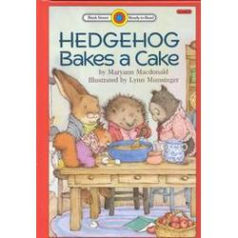  Name:_____________

