1  Picture walk to page 93.  GPS:  Focus: Predict what you think the story is about.  Respond:  _______________________________________________________________________________________________________________________________________________________________________________________________________________________________________________________  ELA2R4b Make  predictions from text | 2  Page 88  GPS:  Focus: What do you like to do in the fall?  Respond:  _______________________________________________________________________________________________________________________________________________________________________________________________________________________________________________________  ELA2R4h Makes connections | 3  Page 93  GPS:  Focus: How is Mudge like the dog in Get Up and Go?  Respond:  _______________________________________________________________________________________________________________________________________________________________________________________________________________________________________________________  ELA2R4h Makes connections
4  Page 93  GPS:  Focus: What parts of this story could be real?  Respond:  _______________________________________________________________________________________________________________________________________________________________________________________________________________________________________________________  ELA2R4f Determines fact from fiction | ?  Page 93  GPS:  Focus: What do you thing they would do together in the winter?  Respond:  _______________________________________________________________________________________________________________________________________________________________________________________________________________________________________________________  ELA2R4b Make  predictions from text | Henry and Mudge Under the Yellow Moon  by:  Cynthia Rylant  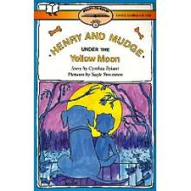  Name:______________

