1  Page 72-73  GPS:  Focus: Why does Emily think Mr. Blueberry can help with her problem?  Respond:  _______________________________________________________________________________________________________________________________________________________________________________________________________________________________________________________  ELA2R4d Infers implicit facts | 2  Page 74-75  GPS:  Focus: Is table salt correct to use to make ocean water? Explain your answer.  Respond:  _______________________________________________________________________________________________________________________________________________________________________________________________________________________________________________________  ELA2R4b Make  predictions from text | 3  Page 80-81  GPS:  Focus: Does a whale really eat cornflakes and bread crumbs?  Respond:  _______________________________________________________________________________________________________________________________________________________________________________________________________________________________________________________  ELA2R4f Distinguish fact from fiction in a text
4  Page 84-85  GPS:  Focus: What does Emily think caused Arthur to leave?  Respond:  _______________________________________________________________________________________________________________________________________________________________________________________________________________________________________________________  ELA2R4k Identifies & infers cause & effect | ?  Page 190-191  GPS:  Focus: Do you think you could keep a whale at home? Explain your answer.  Respond:  _______________________________________________________________________________________________________________________________________________________________________________________________________________________________________________________  ELA2R4h Make connections to personal experiences | Dear Mr. Blueberry  by:  Simon James  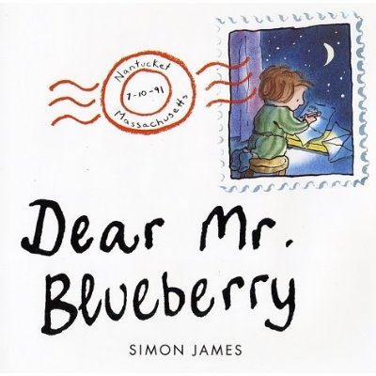  Name:_______________  Date:_________

