1  Page 154  GPS:  Focus: Focus: What is the genre? How is this different from other stories?  Page___  Respond:  _______________________________________________________________________________________________________________________________________________________________________________________________________________________________________________________  ELA2R4m Recognizes elements of the genre | 2  Page 156-157  GPS:  Focus: What is the setting of this story?  Page___  Respond:  _______________________________________________________________________________________________________________________________________________________________________________________________________________________________________________________  ELA2R4l Recognizes plot within a text | 3  Page 158-159  GPS:  Focus: Tell what has happened so far in the story.  Page___  Respond:  _______________________________________________________________________________________________________________________________________________________________________________________________________________________________________________________  ELA2R4e Summarize text content
4  Page 164-165  GPS:  Focus: How did Jeff and Lan know the thief was a bird?  Page___  Respond:  _______________________________________________________________________________________________________________________________________________________________________________________________________________________________________________________  ELA2R4b Makes predictions from text | 5  Page 168  GPS:  Focus: What caused this mystery to happen?  Page___  Respond:  _______________________________________________________________________________________________________________________________________________________________________________________________________________________________________________________  ELA2R4k Identifies cause and effect | Title:  Pine Park Mystery  Author: Tracey West  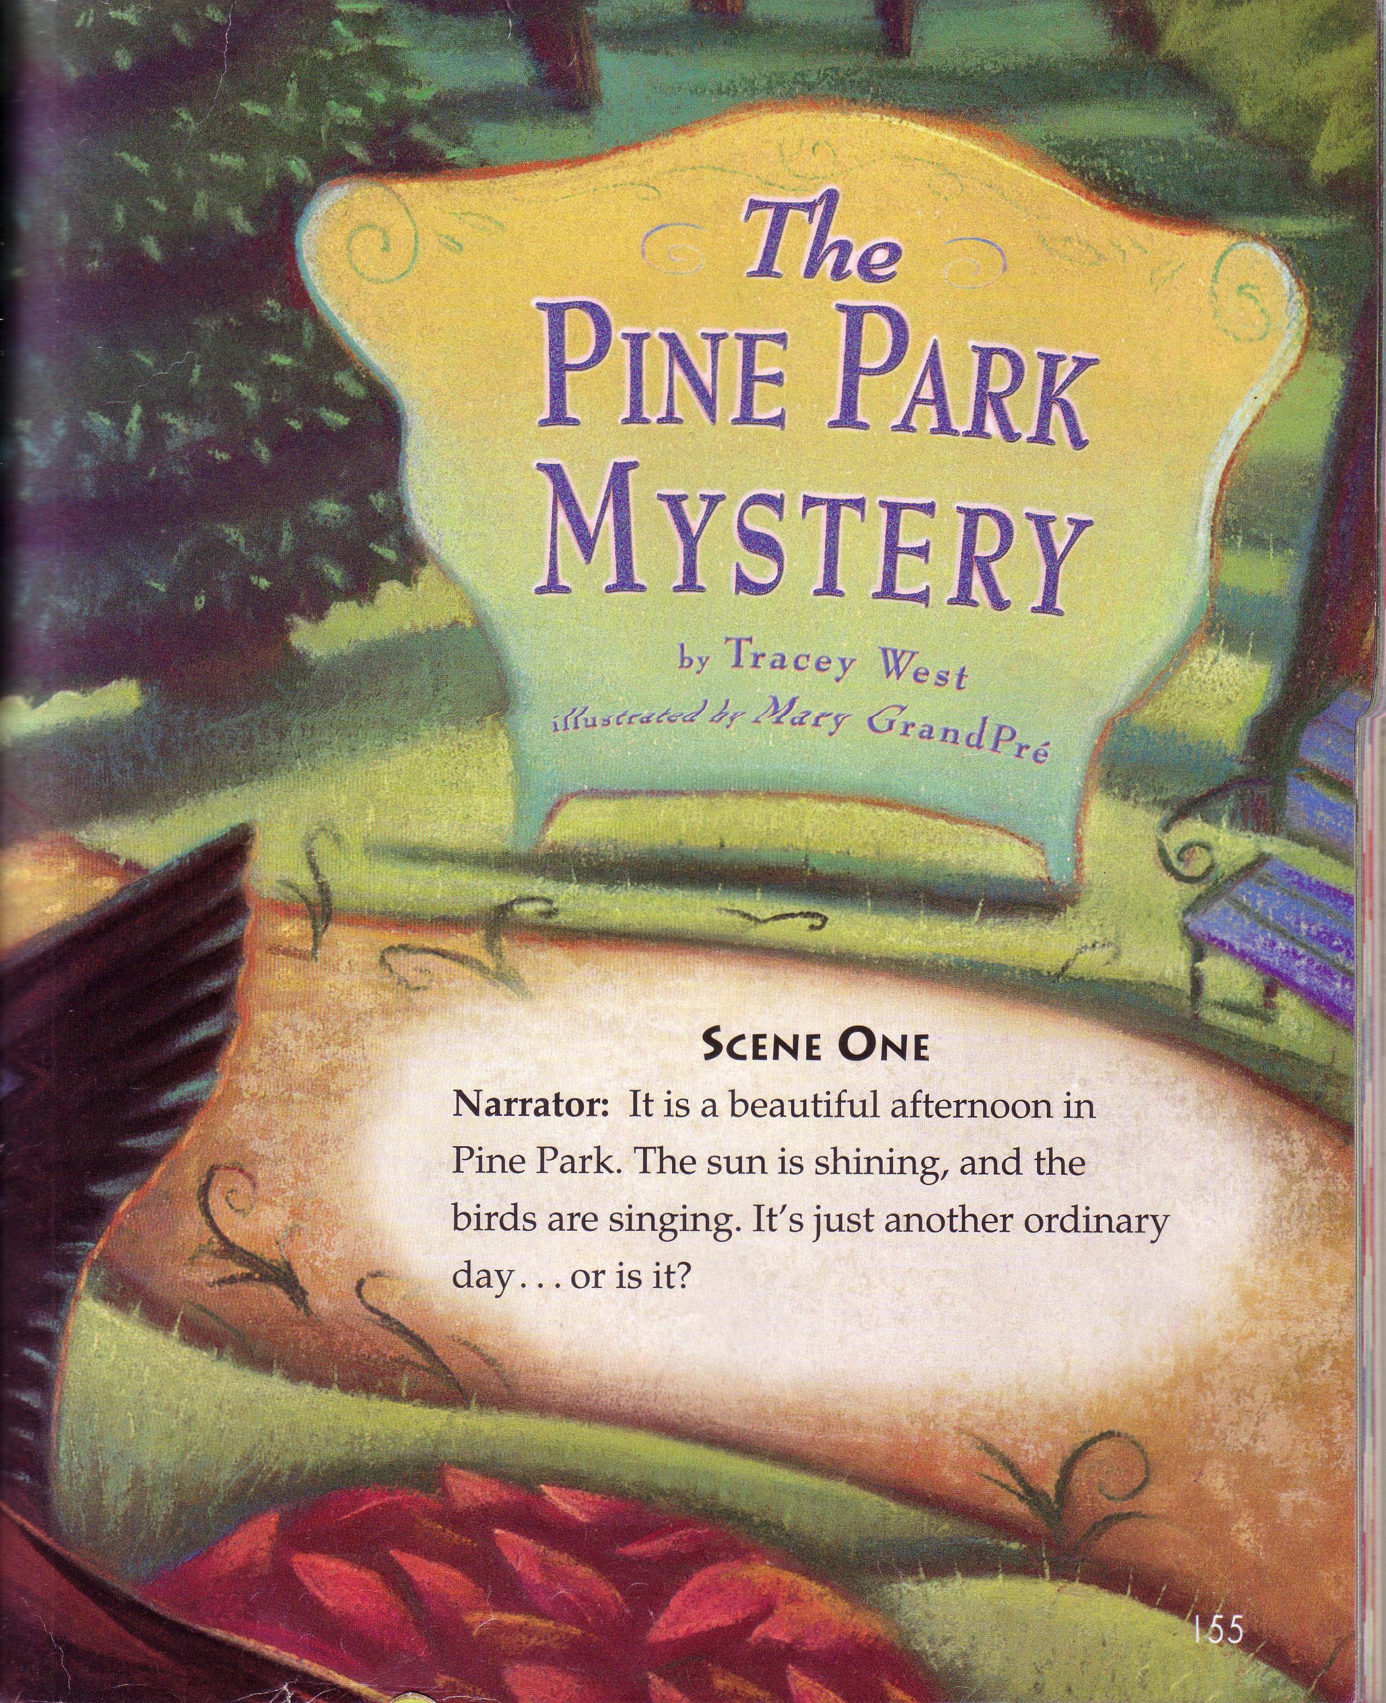  Name:_______________  Date:_________

