1  Page 44-45  GPS:  Focus: Where is Wallace and what is he doing?  Respond:  _______________________________________________________________________________________________________________________________________________________________________________________________________________________________________________________  ELA2R4i Identifies & infers main idea & details | 2  Page 46-47  GPS:  Focus: Do you think this has really happened? Explain your answer.  Respond:  _______________________________________________________________________________________________________________________________________________________________________________________________________________________________________________________  ELA2R4f Distinguish fact from fiction in a text | 3  Page 50-51  GPS:  Focus: What does Wallace mean when he says, “There is more to being a cowboy than boots and a hat”?  Respond:  _______________________________________________________________________________________________________________________________________________________________________________________________________________________________________________________  ELA2R3d Determines meaning on basis of content
4  Page 54-55  GPS:  Focus: What caused the cattle to stampede?  Respond:  _______________________________________________________________________________________________________________________________________________________________________________________________________________________________________________________  ELA2R4k Identifies & infers cause & effect | ?  Page 190-191  GPS:  Focus: Would you like to be a cowboy like Wallace? Explain your answer.  Respond:  _______________________________________________________________________________________________________________________________________________________________________________________________________________________________________________________  ELA2R4h Make connections to personal experiences | How I Spent My Summer Vacation  by:  Mark Teague  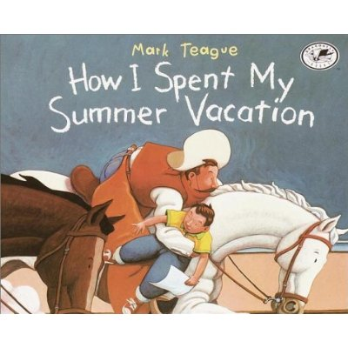  Name:_______________  Date:_________

