Name ___________________________ All That Corn 1
Read the sentences. Circle the word that goes in the sentence, then write it on the line.
- Look at all ___________________ corn!. | that | they
- It looks __________________ big. | little | very
- ______________ did you buy it?. | We | Where
- I want to ______________ corn. | buy | blue
- We can buy corn like______________ . | that | they
Say the pictures with your teacher, then draw a line to match the pictures with the words. |  |  |  | Where that buy
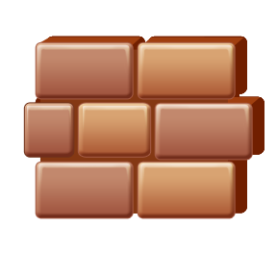  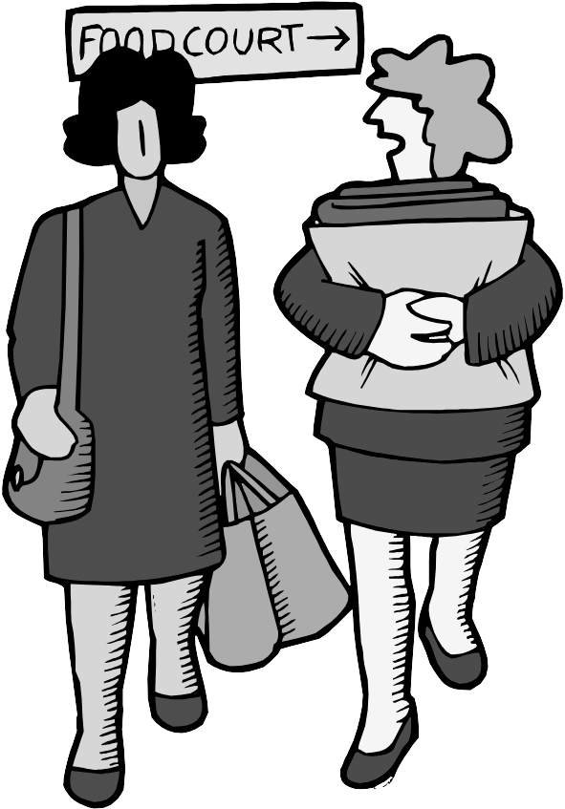 | - mall  - tall  - fall  - ball  - wall  - small |  | 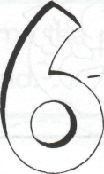  1. __________to give someone money for something  2.__________ to what place  3.___________pointing out someone or thing
Write the number next to contraction.
Match the contractions  - can not ___ can’t  - do not ___ he’s  - he is ___ don’t | - she is ___they’ll  - they will ___ she’s  - we will ___ won’t  - will not ___ we’ll
Name __________________________ All That Corn 2
Read the sentences. Circle the word that goes in the sentence. Then write it on the line.
- Look at all ______________ corn | that | they
- It is ______________ tall corn. | see | very
- It’s as ______________ as a wall. | three | tall
- Pick! Pick all the ______________ . | corn | come
- ______________ will the corn go? | want | Where
Write the words that rhymes words:  tall pack wig  lot pop | Put words in ABC order:  came where ate  black that
- ball ________________  - hop ________________  - big ________________  - not ________________  - sack ________________ | 1. ________________  2. ________________  3. ________________  4. ________________  5. ________________
Read the sentences. Circle the one that is written correctly
- Where is the corn  - Will you pick the corn. | - the corn is in the can  - Where will it go now?
Name ___________________________All That Corn 3
Read the sentences. Circle the word that goes in the sentence. Then write it on the line.

The ________________ is in the cans. | corn | come
- ________________will the cans go? | Walk | Where
- We can buy ______________ at the store. | make | cans
- Where will it go ________________ ? | now | not
- The corn is at ________________ . | home | now
Write the rhyming words.
not  ____ ot | not  ___ ___ ___ | not  i ___ ___ ___
  call  ___ all | call  ___ ___ ___ | call  ___ ___ ___
Circle the correct sentence in each box.
1. Where will the corn go?  2. Where will the corn go. | 1. We will pick the corn.  2. We will pick the corn?
1. The corn is at home.  2. The corn is at home? | 1. Look at all that corn!  2. Look at all that corn?

Name ___________________________All That Corn 4
Read the sentences. Circle the word that goes in the sentence. Then write it on the line.
- Where will it go _______________ ? | now | not
- The _______________ can go pop, pop. | came | corn
- Look at all _______________ corn. | three | that
- I have a _______________ of corn. | bag | big
- Can you help me ____________the corn? | pop | too
Write the words in ABC order.
call wall not  1_____________  2_____________  3_____________ | that buy ate  1_____________  2_____________  3_____________ | black where be  1_____________  2_____________  3_____________
Unscramble and write the sentence correctly.
1 where will it go now__
(W w)here_______________________________________
2. look at all that corn__
(l L)ook________________________________________

