Name __________________________ PP Sam and the Bag 1
Read the sentences. Circle the word that goes in the sentence, then write it on the line.
- Sam ran up _____ down. | away and
- _____ Sam! Help the cat. | Oh Got
- Can you go _____ the bag? | in it
- _____ , you can. | And Yes
- Max ran in the _____ . | big bag
- Max and Hap can _____ in. | jump blue
Say the pictures with your teacher, then circle or color the pictures that have the short a sound.
ă |  | 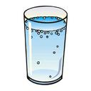  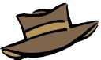  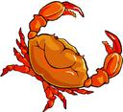
Trace over the letters and then write the missing letter.
a _ c | x _ z
h _ j | m _ o
Name __________________________ PP Sam and the Bag 2
Read the sentences. Circle the word that goes in the sentence. Then write it on the line.
- Max ran _____ the bag. | in | it
- Hap ran in the _____ . | got | bag
- Sam ran _____ the bag. | up | is
- Sam ran _____ the bag. | go | down
- Can Sam _____ in? | yes | go
- _____ ,Sam can go in. | Yes | Blue
Say the pictures with your teacher, then circle 8 pictures that have the sl sound.
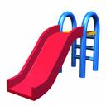  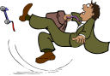  sl | 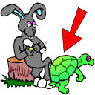  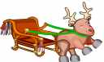 | 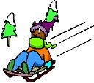  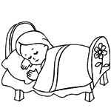
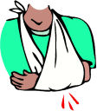
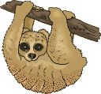
Read the sentences. Circle the one that makes sense.
1. I am Max  2. Max I am. | 1. Up can Sam go.  2. Sam can go up. | 1. Hap can jump in.  2. Can jump Hap in.
1. Hat has a Pam.  2. Pam has a hat. | 1. Jump up Max can.  2. Max can jump up. | 1. Dan got the hat.  2. Hat got Dan the.
Name __________________________ Sam and the Bag 3
Read the sentences. Circle the word that goes in the sentence. Then write it on the line.
- Can Dan ________ Sam? | here | help
- The cat _______ away. | can | ran
- Dan _______ the cat. | got | go
- Can Pam ______ the hat? | find | big
- Sam, come and _____ Max. | funny | help
- Max can go down ______ . | here | oh
Write the rhyming words.
tap  ____ ap | tap  ____ ap | 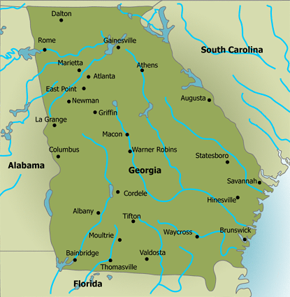  tap  ____ ap
tag  ____ ag |   tag  ____ ag | tag  ____ ag
Unscramble and write the sentence correctly.
1 Dan hat the got.
Dan_____ ______________
2. Sam bag ran down the.
Sam_____ ______________
Name __________________________ Sam and the Bag 4
Read the sentences. Circle the word that goes in the sentence. Then write it on the line.
- Sam helps the ______ cat. | here | funny
- Yes, Pam can go _______ . | oh | here
- Funny Max ____ in the hat. | ran | is
- The ____ cat sat on the rat. | big | away
- Max, the cat ____ on the mat. | blue | sat
- Pam ran up and ______ | go | down
Write the words in ABC order.
bag cap am  1_____  2_____  3_____ | ham mad tap  1_____  2_____  3_____ | cat at hat  1_____  2_____  3_____
Unscramble and write the sentence correctly.
1 Can the go in bag Max.
Can_____ ______________
2. Hap in bag the ran.
Hap_____ ______________

