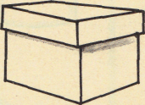
Name __________________________ PP Todd’s Box 1
Read the sentences. Circle the word that goes in the sentence. Then write it on the line.
- Look , Mom! I can _____ . | don’t | dig
- I can dig in the _____ . | said | sand
- Not _____ , Todd. | now | my
- Hop ____ the rocks, Todd . | off | one
- Look, Mom! The ant is __ fast. | see | so
Write the missing vowel o or i
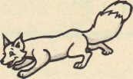  f x__ | 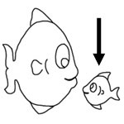  _f sh_ | 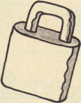  l ck
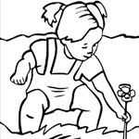  _d__g | _k_ ck | 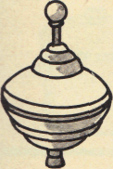  _t__p
Write the sentences correctly. Capital- first word of sentence, . ?
- the cat is big and fat
______________________
- will the big dog run after me
______________________

Name __________________________ PP Todd’s Box 2
Read the sentences. Circle the word that goes in the sentence. Then write it on the line.
- Don’t _____ up the ant, Todd! | pick | play
- Look at the _____ , Mom. | pond | little
- We _____ to go home, Todd. | come | have
- Mom, here is a _____ for you. | come | gift
- It is a _____ of ants, Mom. | box | blue
Listen to the vowel sound. Write an o or _i under the correct picture to match the sound.
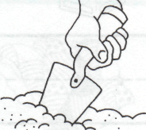

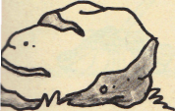
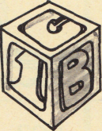
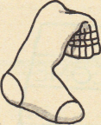
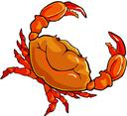

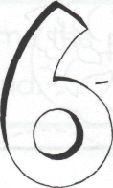
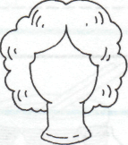
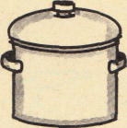
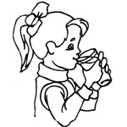
_ _ _ _ _ _
_ _ _ _ _ _
Read the sentences. Trace over the correct Put the words in ABC order
letter. Put a or ? in the box.
- W w here is my cat  - W w ill you help me  - I i t is a box of surprises | too of want don’t  1.___ 2.____  3.___ 4.___
Name __________________________ PP Todd’s Box 3
Read the sentences. Circle the word that goes in the sentence, then write it on the line.
- ____ play in the sand. | I’ll | don’t
- The cats ____ like to play | she ’ll | don’t
- ____ jump in the pond. | He’ll | don’t
- They ____ like to play in the sand | she’ll | don’t
- ____ jump on the bed. | I’ll | Don’t
Say the pictures with your teacher, then circle or color the pictures that have the short o sound.
ŏ |  |   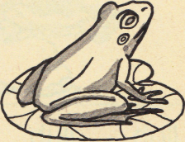  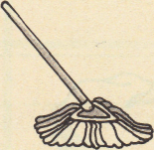
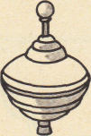
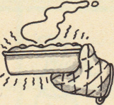
Match word to what it means. Add the endings to make a new word.
1. Don’t -  2. So-  3. Of-  4. Too-  5. Want- | - Therefore  - Do not  - To wish  - Taken from  - also | - help + ing ______  - walk + ed ______  - look + ing ______  - make + s ______
Name __________________________ PP Todd’s Box 4
Read the sentences. Circle the word that goes in the sentence. Then write it on the line.
- Don’t sit on the ______ . | box | hot
- Do you ______ the i ? | not | dot
- Sam will ______ up the ants. | stick | pick
- Mom dropped the hot _____ . | not | pot
- Todd is ______ now. | back | tack
Write the vowel sounds for the pictures. a o i
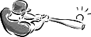
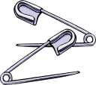


_ _ _ _ _ _
_ _ _ _ _ _
Unscramble and write the sentence correctly.
1 sand can in I dig the
I_____ ______________
2. will We pond to the go.
We_____ ______________

