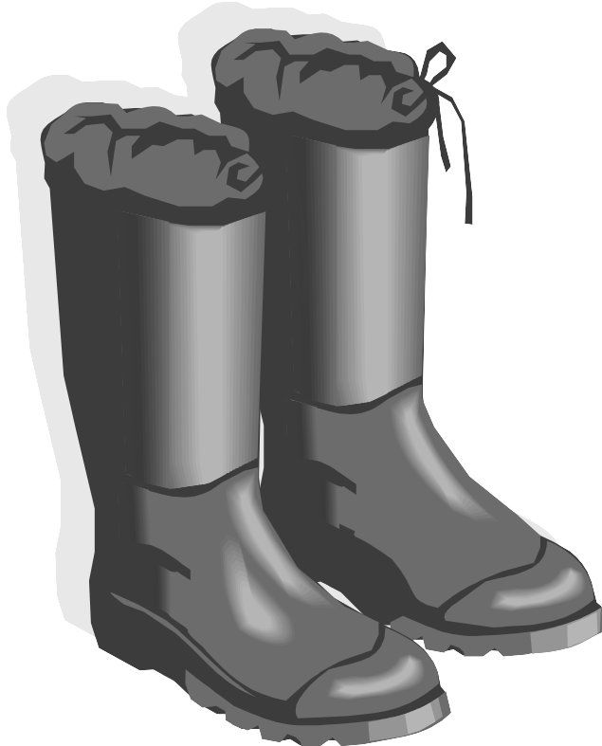
Name __________________________Boots for Beth < 1
Read the sentences. Circle the word that goes in the sentence. Then write it on the line.
- Beth’s _________________ got a new hat. | friend | funny
- She _________________it on. | put | play
- _________________said “It is too big.” | See | She
- Meg _________________ use a hat. | could | come
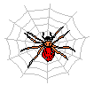  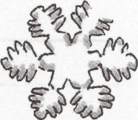  - You can _________________ use my bike. | up | Use
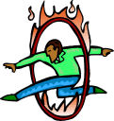
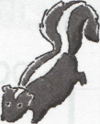
Match the words to the pictures. ABC order
- through  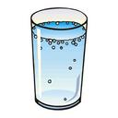  - thimble  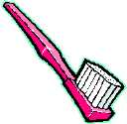  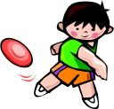  - toothbrush  - throw    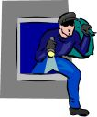  - think  - thief | New must like out  1._____________________  2._____________________  3._____________________  4._____________________
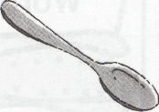  Circle the naming part of the sentences.  - The fox ran down the hill.  - My cat is not here. | - The eggs are in a nest.  - The dogs ran in the park.  - Three pigs ate the corn.

Name ________________________Boots for Beth- 2
Read the sentences. Circle the word that goes in the sentence, then write it on the line.
- “My .______________don’t fit,” said Beth. | boot | boots
- I can not get _______________on. | they | them
- _______________you use my boot? | Could | Came
- They are _______________big for me. | too | two
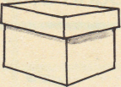  - Do you _______________my pink boots? | walk | want
Match the Opposites. Add a c in front a/ o/ u / words parts Add a k in front of e/ i/ y/ words parts
Add C or K
- little  - now  - here  - come  - run | ___then  ___away  ___big  ___walk  ___go | - _____ub  - _____it  - _____at  - _____op  - _____up | 6. _____eep  7. _____ut  8. _____ag  9. _____ot  10. _____iss
Write the beginning sounds for the pictures. sk sl sp st sn sm
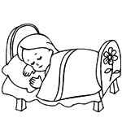
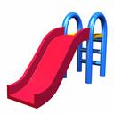
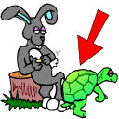
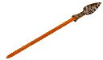
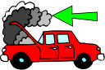

_____ _____ _____ _____ _____ _____ _____ _____
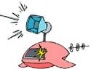
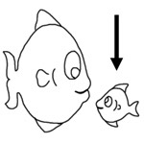
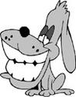
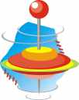
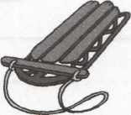
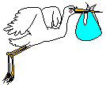

_____ _____ _____ _____ _____ _____ _____ _____
Name _______________________ Boots for Beth >3
Read the sentences. Circle the word that goes in the sentence. Then write it on the line.
- Ted, your boots .______________too wet. | are | car
- Can you ._____________ on Jeff’s black boot? | but | put
- “It is too .______________ ,” said Beth. | thin | chin
- Beth’s .______________ all felt bad. | friends | tends
- They got a big ._____________ for Beth. | sunrise | surprise
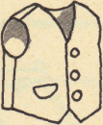
Write an o or _e under the correct picture to match the sound.
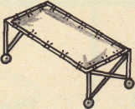
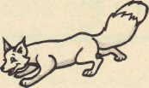
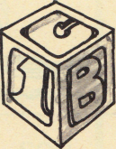
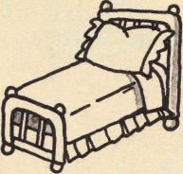
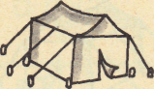
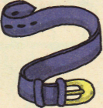
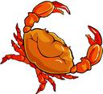

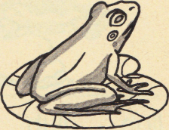
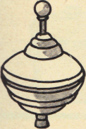
_____ _____ _____ _____ _____ _____
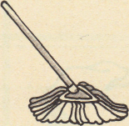
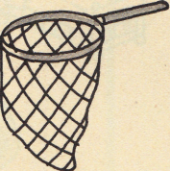

_____ _____ _____ _____ _____ _____
Contraction- Write the two words. n’t = not ‘ll = will
- don’t 1. do not  - can’t 2. ______ _______  - isn’t 3. ______ _______ | 4. she’ll 4. ______ ______  5. they’ll 5. ______ ______  6. he’ll 6. ______ _____
Name _________________________ Boots for Beth -4
Write the two words for the contractions. n’t = not ‘ll = will ‘s = is
- Beth and her friends can’t go to the zoo. | _______ ______
- He’ll find the lost boot. | _______ ______
- He’s playing a video game. | _______ ______
- Jeff isn’t helping Max with the work. | _______ ______
- Dan didn’t find the lost cat. | _______ ______
Use a line to connect the words to the pictures.
  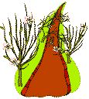  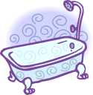  bath  toothbrush  wreath  path | 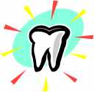  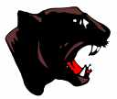    tooth  thumb    earth  throw
Use and to make two sentences into one sentence.
- Ted can run. Ted can play.

Ted can _________________________________________
_______________________________________________
2. Sam will run. Sam will play.

Sam will_________________________________________
________________________________________________

