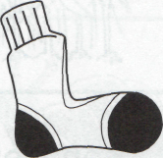
Name ______________________________ Dan’s Pet 1
Read the sentences. Circle the word that goes in the sentence. Then write it on the line.
- Where _________________ my pet, Jen. | was | where
- Will you go _________________ me. | we | with
- I will call _________________ for you. | now | her
- We will see her _________________ day. | every | not
- Mom ____ , “ We will go today.” | said | find
Write the rhyming words.
Ben  ____ en | Ben  ___ ___ ___ |   Ben  ___ ___ ___
red  ____ed | red  ___ ___ ___ ____ | red  ___ ___ ___ ___
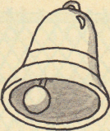
Join the two sentences to make one sentence. Don’t forget to us the word “and”.
Circle the correct sentence in each box.
1. Rick can run. Ted can run.

Rick ___________________________________________
_______________________________________________

2. Sam will play. Todd will play.

Sam_____________________________________________
_______________________________________________

Name _______________________________ Dan’s Pet 2

Read the sentences. Circle the word that goes in the sentence. Then write it on the line.
- Dan __________________the baby chick. | come | held
- It was__________________in his hands | soft | make
- Can I __________________her as a pet? | have | up
- “I’ll call her Red,” _________________Dan. | away | said
- Dan __________________all the hens. | blue | fed
Draw a line from the word to the picture.
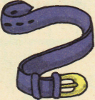  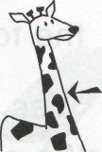  - belt  - frog  - neck  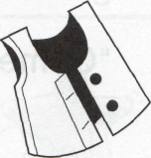    - doll  - vest | 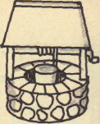  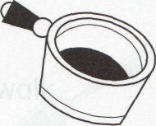  - net  - pot  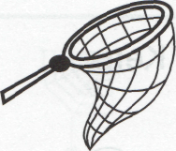  - bell  - sock  - well
Match the words that are opposites.
- up  - come  - boy  - little | __ go  _1_ down  __ girl  __ big | - can  - do  - is  - are | __ isn’t  __ don’t  __ aren’t  __ can’t

Name _______________________________Dan’s Pet 3
Read the sentences. Circle the word that goes in the sentence. Then write it on the line.
- Dan fed Red ___________________ day. | every | with
- The hen got ___________________ big. | her | very
- One day, Dad ________________ see Red. | day | didn’t
- Red___________________has three eggs. | every | now
- Dan now has __________________of pets. | lots | was
Write the vowel sounds for the pictures. e o i
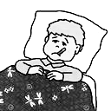
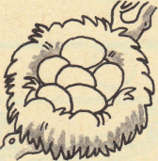
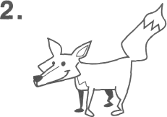

____ ____ ____ _____ ____ ______
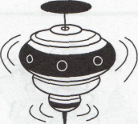

____ ____ ____ _____ ____ ______

Words that go together:
- day  - every  - her  - said  - was | __ each  _1_ night  __ say  __ were  __ his | - is  - little  - to  - walk  - red | __ blue  _6_ are  __small  __too  __run

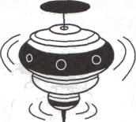
Name _______________________________ Dan’s Pet 4
Read the sentences. Circle the word that goes in the sentence, then write it on the line.
- We can run ________________ fast. | do | so
- What will we ________________ here? | but | buy
- Dan ________________ call the pets. | didn’t | isn’t
- Where ________________ Sid’s cat now? | in | is
- I ________________to go in the pond. | want | will
A Say the pictures, and then draw a line  to match the pictures with the words. |  |  |  | ABC order  call we red | ABC order  to end send
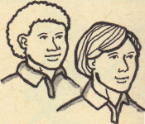 | - hen  - pen  - men  - tent  - nest  - net |  | 1. _________  2. _________  3__________ |  | 1. _________  2. _________  3__________
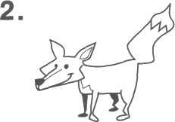
Write the two words for the contractions:  n’t = not, ‘s = is ‘ll= will |  | Write the two words for the contractions:  n’t = not ‘s = is ‘ll= will
- don’t  - can’t  - she’s  - he’ll | Do not  _______ _______  _______ _______  _______ _______ | - we’ll  - he’s  - aren’t  8. isn’t | we will  _______ _______  _______ _______  _______ _______

