Name ____________________ Fun With Fish 1-2 1
Read the sentences. Circle the word that goes in the sentence, then write it on the line.
- Little fish need little ________________. | food | front
- Some little fish ___________ in the grass. | hide | has
- ____________ little fish just swim away. | Make | Many
- Some fish look _______________to us. | fast | funny
- ________________ do some fish swim. | How | Here
Write the beginning sounds and ending sounds for the pictures.
1. ___u _  2. ___o____  3. ___a____  4. ___ig___ | 5. __ oc___  6. __ _ai___  7. ___ el___  8. ___ i _ __
Circle Yes - if rhymes Circle No - if not
- Yes No ship hip  - Yes No dish dig  - Yes No for fork  - Yes No be tree | - Yes No dash dish  - Yes No fly flag  - Yes No wish dish  - Yes No shot spot

Name ____________________ Fun With Fish 1-2 2
Read the sentences. Circle the word that goes in the sentence. Then write it on the line.
- Put on _________________ flippers. | some |  | same
- Jump in and _________________ down. | swim | soon
- _________________ helps the fish swim? | How | What
- Tails and_________________ help fish swim. | fins | fun
- Fish use __________________ tails to swim. | they | their
Write the nouns and verbs to match the picture.
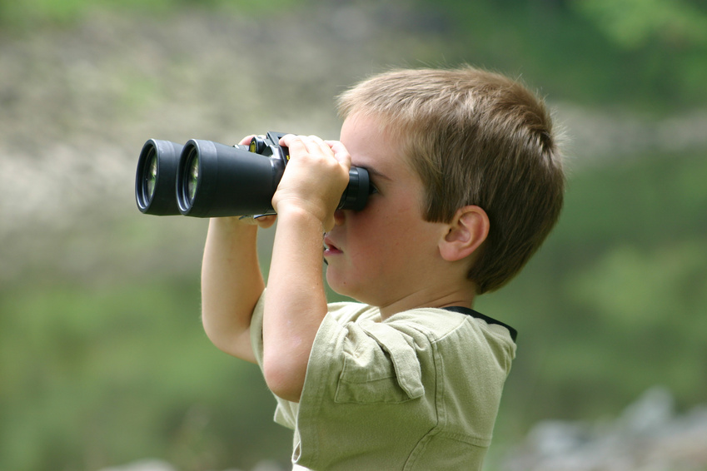  mask food fish ship  _________________  _________________  _________________  _________________ | hop swim walking fly  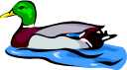  _________________  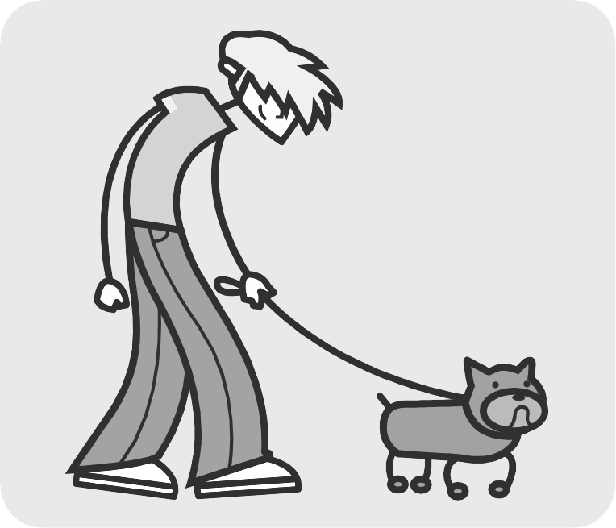  _________________  _________________  _________________
Compound Words: Match the words that go together. Write the number on the line
1. to  2. see  3. rain  4. lunch | ___day  ___saw  ___coat  ___box | 5. frog  house room  saw  walk  ball  day  bow  6. dog  7. clown  8. in | ___to  ___legs  ___fish  ___bowl
Name ____________________ Fun With Fish 1-2 3
Read the sentences. Circle the word that goes in the sentence, then write it on the line.
- Some fish like to________________ plants. | eat | enough
- _________________ big fish eat small fish. | more | many
- How do small fish get _______________? | any | away
- Some fish _______________ in the sand? | hide | has
- Clown fish may look _________________ . | funny | from
A 1 for one M for more than one |  | ABC order ship dish wish more be try
1. frog___  2. dishes___  3. boys___ | 4. girl___  5. cats___  6. ship___ | 1. __________  2. __________  3. __________ | 4. __________  5. __________  6.__________

Write the nouns on the line.
- jump  - fish  - apple  - run  - bug  - frog | 1________________  2________________  3________________  4________________ | - day  - bat  - played  - puppy  - skip  - eggs | 1________________  2________________  3________________  4________________
Name ____________________ Fun With Fish 1-2 4
Read the sentences. Circle the word that goes in the sentence. Then write it on the line.

- Some fish are _____ . | friends | from
- This puffer fish can ____ up. | pond | puff
- ___ did the fish help the diver? | Has | How
- Fish use _____ tail fins to swim. | their | think
- This fish eats bits of ___ off the shark. | food | funny
Syllables = 1, 2 | Opposites: run in happy good up over night
- brown_____  - pretty _____  - funny_____  - good _____  - help_____  - many_____  - to_____  - we_____  - baby_____ | - down ___________________  - under ___________________  - walk ___________________  - day ___________________  - out ___________________  - sad ___________________  - bad ___________________

