Name __________________________ Space Pups 1
Read the sentences. Circle the word that goes in the sentence. Then write it on the line.
- Gus isn’t like _____________ dog. | you | your
- _____________ can you go home. | When | With
- When _____________ come, he goes out. | now | night
- Gus gives help to _____________ . | people | pretty
- He _____________ , “Here I come.” | says | saw
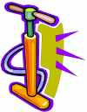

Match the words to the pictures. Opposite: Match words that go together.
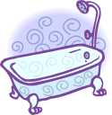  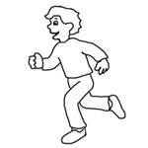  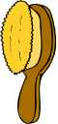  • plug •  • pump •  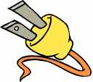  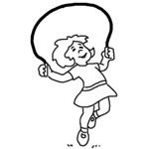  • tub •  • bus •  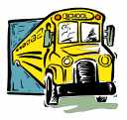  • brush •  • jump • | Night •  all •  play • | •none  •work  •day
 | ride •  come •  he • | •walk  •she  •go
Match the beginning of the sentence with the end of it. Write the number on the line.
- The hungry pig ____hopped away.
- The bunny ____hid in a box.
- The birds ____ate all the corn.
- The scared cat ____flew in a tree.
Name ____________________________Space Pups 2
Read the sentences. Circle the word that goes in the sentence, then write it on the line.
- Gus can not _____________ at night. | rest | red
- Space Pup helps _____________ . | people | put
- Space Pup sees a _____________ . | big | bus
- The bus is _____________ in the mud. | she | stuck
- __________ sees people stuck in the bus. | He | here
Write the beginning sounds for the pictures. st sp sh
- ______ eps  - ______ ar  - ______ aceship  - ______ op sign | 5. ______ oon  6. ______ eep  7. ______ ool  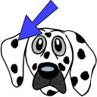  8. ______ ot
Circle Yes if it rhymes Circle No if it does not.
- Yes No pot dot  - Yes No blue you  - Yes No oh one  - Yes No men hen | - Yes No at ate  - Yes No mug bug  - Yes No call ball  - Yes No play but
Name ____________________________ Space Pups 3
Read the sentences. Circle the word that goes in the sentence. Then write it on the line.
- “Here I come,” _____________ Space Pup. | yell | your
- “Hand me _________ rope,” said Space Pup. | yell | your
- What will you do _____________ it? | with | when
- I’ll get the bus _____________ of the mud. | out | one
- He _____________ the rope a big tub. | got | gives
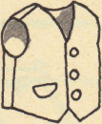
Write an o or _u under the correct picture to match the sound.
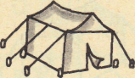
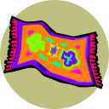
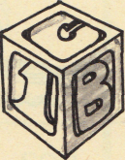
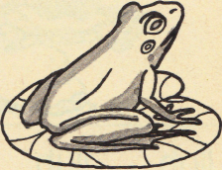
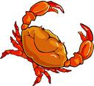
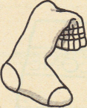
____ ____ ____ ____ ____ ____
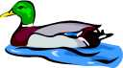
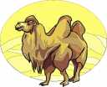
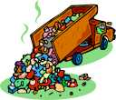
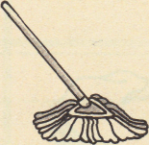
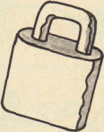

____ ____ ____ ____ ____ ____
Contraction- Write the two words. n’t = not ‘ll = will
- can’t  - doesn’t  - isn’t | can not  _____ _____  _____ _____ | 4. we’ll  5. I’ll  6. she’ll | _____ ______  _____ ______ ______ _____
Name ____________________________Space Pups 4
Read the sentences. Circle the word that goes in the sentence. Then write it on the line.
- Space Pup is the _____________ . | best | blue
- Space Pup helps __________ at night. | people | play
- Gus the Pup _____________ all day. | red | rest
- __________ the sun is up, Pup rest. | When | Want
- He helped the _____________ on the hill. | ants | away
Fill in the missing letters: gl cl pl bl fl
1. _____ower  2. ______own  3. ______ate  4. _______ag | 5. ____ock  6. ____ oud  7. _____asses  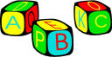  8. _____ock
Fix and write the sentences correctly.
- the people will help me_

____________________________________________________

2. when are you going to eat_
_____________________________________________________

