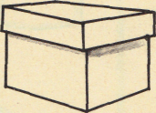
Name __________________________ PP Todd’s Box 1

Read the sentences. Circle the word that goes in the sentence. Then write it on the line.
- Look , Mom! I can ________________ . | don’t | dig
- I can dig in the ________________. | said | sand
- Not ________________, Todd. | now | my
- Hop _____________ the rocks, Todd . | off | one
- Look, Mom! The ant is __________ fast.   | see | so
Write the missing vowel o or i
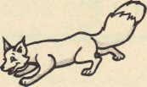  F____x | 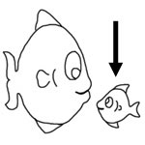  f____sh | 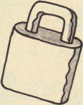  l____ck
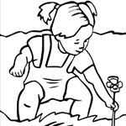  d____g | k____ck | 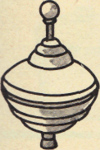  t____p
Write the sentences correctly. Capital- first word of sentence .
.
?

- the cat is big and fat____

________________________________________________

- will the big dog run after me____

________________________________________________

Name __________________________ PP Todd’s Box 2
 
Read the sentences. Circle the word that goes in the sentence. Then write it on the line.
- Don’t ________________ up the ant, Todd!   | pick | play
- Look at the ________________, Mom. | pond | little
- We ________________ to go home, Todd. | come | have
- Mom, here is a ________________ for you. | come | gift
- It is a ________________ of ants, Mom.    | box | blue
Listen to the vowel sound. Write an o or _i under the correct picture to match the sound.
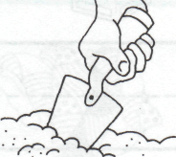

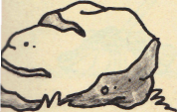
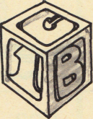
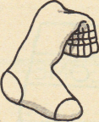
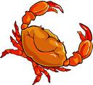
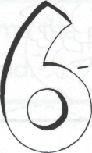
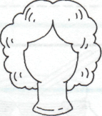
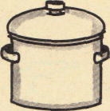
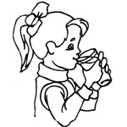
___ ___ ___ ___ ___ ___

___ ___ ___ ___ ___ ___
Read the sentences. Write the correct Put the words in ABC order
☑ 
 
letter. Put . or ? in the box.
W w I i  - ______here is my cat  - ______ill you help me  - ______t is a box of surprises  - This ______s my cat | too of want don’t  1. _______________  2. _______________  3. _______________  4. _______________

Name __________________________ PP Todd’s Box 3
 
Read the sentences. Circle the word that goes in the sentence, then write it on the line.
- _______________ play in the sand. | I’ll | don’t
- The cats ________________ like to play | she ’ll | don’t
- ________________ jump in the pond. | He’ll | don’t
- They _______________ like to play in the sand | she’ll | don’t
- ________________ jump on the bed. | I’ll | Don’t
Say the pictures with your teacher, then circle or color the pictures that have the
short o sound.
ŏ |  |   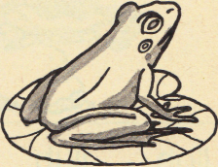  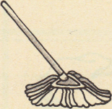
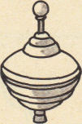
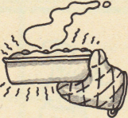
Match word to what it means. Add the endings to make a new word.
 
1. Don’t -  2. So-  3. Of-  4. Too-  5. Want- | - Therefore  - Do not  - To wish  - Taken from  - also | - help + ing  __________________________________________  - walk + ed  __________________________________________  - look + ing  __________________________________________  - make + s  __________________________________________
Name __________________________ PP Todd’s Box 4
 
Read the sentences. Circle the word that goes in the sentence. Then write it on the line.
- Don’t sit on the ________________. | box | hot
- Do you ________________ the i ? | not | dot
- Sam will ________________ up the ants. | stick | pick
- Mom dropped the hot _______________. | not | pot
- Todd is ________________ now.  ☺  | back | tack
Write the vowel sounds for the pictures. a o i

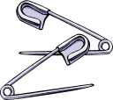
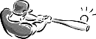
___ ___ ___ ___ ___ ___

___ ___ ___ ___ ___ ___

Unscramble and write the sentence correctly.
 
1. sand can in I dig the

I____________________________________

2. will We pond to the go.

We____________________________________

