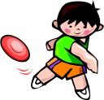
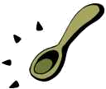
Name _________________________ Try Your Best 1
Read the sentences. Circle the word that goes in the sentence. Then write it on the line.
- Jan and Ann are ______________ friends. | good | grow
- Jan ______________ Ann looking sad. | saw | soon
- It’s time for ______________ day camp. | think | our
- You just ______________ to try. | team | need
- Jan is ______________ , I will try. | look | right
Write the short vowel sounds for the pictures. e o i a u
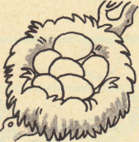
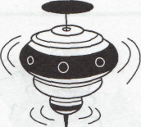

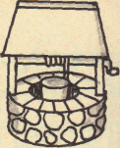
_____ _____ _____ _____ _____

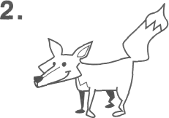

_____ _____ _____ _____ _____
Words that go together:
- day  - right  - her  - said  - jump | ____ left  _1__ night  ____ say  ____ hop  ____ his | - is  - little  - tadpole  - walk  - by | ____ buy  ____ are  ____ small  ____ frog  ____ run
Name _________________________ Try Your Best 2
Read the sentences. Circle the word that goes in the sentence, then write it on the line.
- It is a ______________ day for sports. | good | gone
- I’m not ______________ good at sports. | want | very
- Just ______________ your best, Ann. | this | try
- It is ______________ for Mort to kick. | time | that
- “What a kick,” ______________ Mort. | said | say
Write the beginning sounds for the pictures. pl sm fl sl br sp st
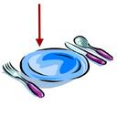  1. ____ ate    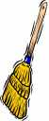  2. ____ ower  3. ____ oom  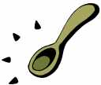  4. ____ oon | 5. ____ ool  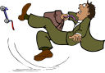    6. ____ ip  7. ____ ile  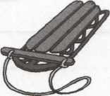  8. ____ ed
Circle Yes if rhymes Circle No if not
- Yes No blue too  - Yes No are star  - Yes No fork fort  - Yes No cork stork | - Yes No or for  - Yes No corn farm  - Yes No more much  - Yes No hang bang
Name _________________________ Try Your Best 3
Read the sentences. Circle right the word. Then write it on the line.
- You ______________ us score, Mort. | helped | here
- Next, you will ______________ the rope. | come | climb
- Now it is time to run a ______________ . | play | race
- We need one _____________ to play ball. | more | make
- You can be on our ______________ . | team | time
Compound words are two words put together make one word.
in______________  can______________  may______________ | be  to  not | see______________  with______________  dog______________ | house  out  saw
Classifying: Write the word that go with the first two.
- blue brown ________________ | red read
- tiny small ________________ | little big
- pond sea ________________ | lake tree
- saw look ________________ | race see
5. run hop ________________ | jump sit
Name ________________________ Try Your Best 4
Read the sentences. Circle the word that goes in the sentence, then write it on the line.
- I ______________ run very fast. | isn’t | can’t
- ______________ try to do my best. | I’ll | He’s
- ___________ need one more for our team. | We’ll | Don’t
- ___________ going to be on our team now. | Can’t | She’s
- We ____________ want the frog to help. | don’t | he’s
Say the pictures, and then write the number to match the word to the picture. |  |  |  | ABC order  good time right our try be
 | - cork  - swing  - fork  - king  - corn  - ring |  | 1. _________  2. _________  3. _________ |  | 4. _________  5. _________  6. _________
Match the words that are opposites.
- boy  - come  - little  - up | __ go  _1_ down  __ girl  __ big | - is  - can  - do  - are | __ isn’t  __ don’t  __ aren’t  __ can’t

