Name ____________________ “Where Do Frogs Come From” 1
g
Read the sentences. Circle the word that goes in the sentence. Then write it on the line.
- A frog ________ fast. | grows | gone
- Where do frogs come ____ ? | find | from
- What do frogs ______ ? | eat | eggs
- A frog has ____ long legs. | two | to
- Now the frog is ______ .  b  an | got | gone
Blends: Match the words to the pictures. ABC order
  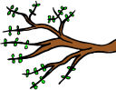  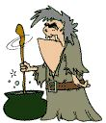  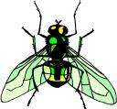  blow  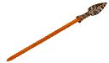  spear  branch  skirt  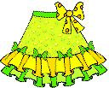  fly  stir |  | from went gone what  1.________  2.________  3.__________  4._________
c
Match the words to the contraction .
- can not   - is not   - will not   - are not  | ● isn’t   won’t   aren’t   can’t |  | 5.he will   6. he is   7. she will   8. he is  | ● she’s   he’ll   she’ll   he’s
Name ____________________ “Where Do Frogs Come From” 2
r
Circle the word that goes in the sentence. Then write it on the line.
- Frogs come _____ small eggs. | frog | from
- The black ____ are frog eggs. | this | things
- A fish can ____ the tadpoles. | eat | each
- The tadpole eats and ____ . | grows | blue
- It grows ____ strong back legs.  b | two | to
Use a line to connect the words to the pictures. (digraph – ng/ and blend – sl/)
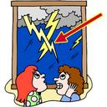    duckling  fang  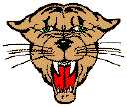  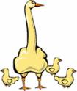  lightning  sling  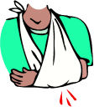  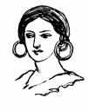  bowling  earrings  F | 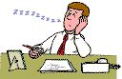  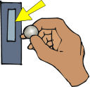  slow  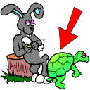  slot  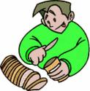  slice  slip  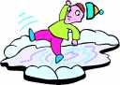  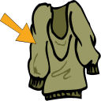  sleeve  sleep
Circle the verb- A verb is an action word or something you can do.
- The duck swims in the pond.  - The little frog hops.  - The boy jumps in the lake. | - My cat ran away.  - Todd walks to the park.  - The tadpole grows into frogs.
Name ____________________ “Where Do Frogs Come From” 3
w
Read the sentences. Circle the word that goes in the sentence. Then write it on the line.
- It grows two ____ front legs. | saw |  | small
- Now the tadpole is a big strong ____ . | frog | from
- The frog can now hop and ____ . | plop | bugs
- Frogs eat lots of ____ . | but | bugs
- The bugs are not as ____ as the frogs.  d | funny | fast
Write the verb for the picture. Verbs are action words.
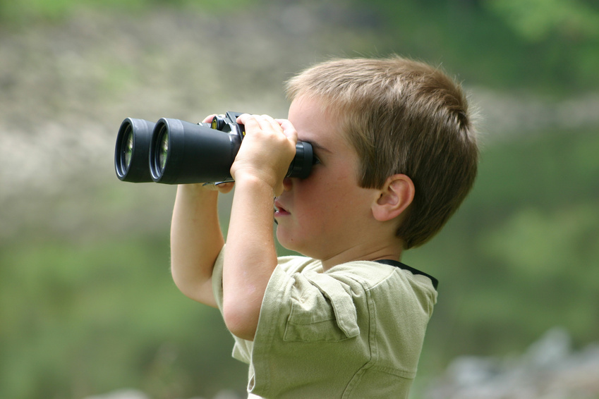  hop swim jump look  ________  ________  _________  _________  u | go eat ride make  ________  ________  _________  _________
Rhyming words: If the pair of words rhymes circle yes. If the pairs does not rhyme circle no
- bugs – rugs | yes no | - from - front | yes no
- go - to | yes no | - they – that | yes no
- ride - hide | yes no | - down - town | yes no
Name ____________________ “Where Do Frogs Come From” 4
p
Read the sentences. Circle right the ending. Then write it on the line.
- They help_ the frog jump away. | s ed ing
- Two frog_ ate the little bugs. | s ed ing
- What are you say_ to the frog? | s ed ing
- The tadpole is eat_ lots of plants. | s ed ing
- The boys are look_ for tadpoles.  t | s ed ing
Write the short vowel sounds for the pictures. a e i o u
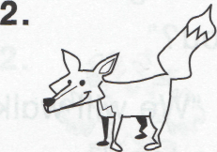
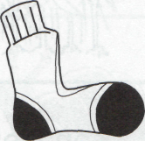
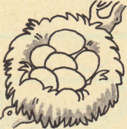
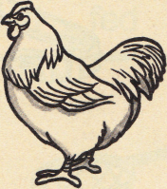
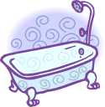
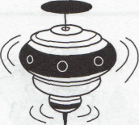
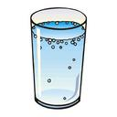
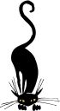
_ _ _ _ _ _
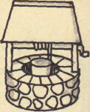
_ _ _ _ _ _
o
Classifying: Write the words that go with the first two.
- two to ______ | too big
2. frog tadpole ______ | nest eggs
3. jump hop ______ | eat run

