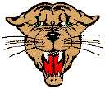
Name _________________________ “Where Do Frogs Come From” 1
Read the sentences. Circle the word that goes in the sentence. Then write it on the line.
- A frog _______________ fast. | grows | gone
- Where do frogs come _____________ ? | find | from
- What do frogs _______________ ? | eat | eggs
- A frog has ______________ long legs. | two | to
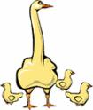  - Now the frog is _______________. | got | gone
Blends: Match the words to the pictures. ABC order
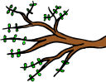  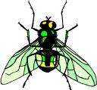  blow  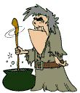  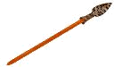  spear  branch    skirt  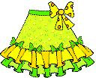  fly  stir |  |  | from went gone what  1._________________  2._________________  3._________________  4._________________
Match the words to the contraction .
- can not   - is not   - will not   - are not  | ● isn’t   won’t   aren’t   can’t | 5.he will   6. he is   7. she will   8. he is  |  | ● she’s   he’ll   she’ll   he’s
Name _________________________ “Where Do Frogs Come From” 2
Circle the word that goes in the sentence. Then write it on the line.
- Frogs come ________________ small eggs. | frog | from
- The black _______________ are frog eggs. | this | things
- A fish can ________________ the tadpoles. | eat | each
- The tadpole eats and _________________. | grows | blue
- It grows _____________ strong back legs. | two | to
Use a line to connect the words to the pictures. (digraph – ng/ and blend – sl/)
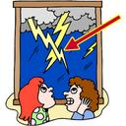  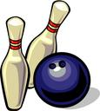  duckling  fang  lightning  sling  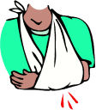  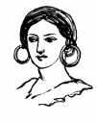  bowling  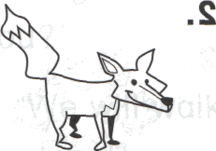  earrings | 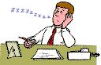  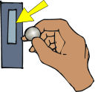  slow  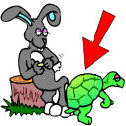  slot  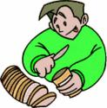  slice  slip  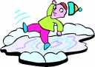  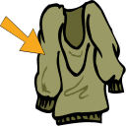  sleeve  sleep
Circle the verb- A verb is an action word or something you can do.
- The duck swims in the pond.  - The little frog hops.  - The boy jumps in the lake. | - My cat ran away.  - Todd walks to the park.  - The tadpole grows into frogs.
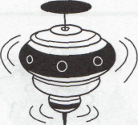
Name ____________________ “Where Do Frogs Come From” 3
Read the sentences. Circle the word that goes in the sentence. Then write it on the line.
- It grows two _______________ front legs. | saw |  | small
- Now the tadpole is a big strong ___________. | frog | from
- The frog can now hop and _______________. | plop | bugs
- Frogs eat lots of _______________. | but | bugs
- The bugs are not as __________as the frogs. | funny | fast
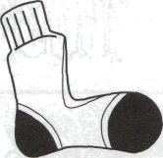
Write the verb for the picture. Verbs are action words.
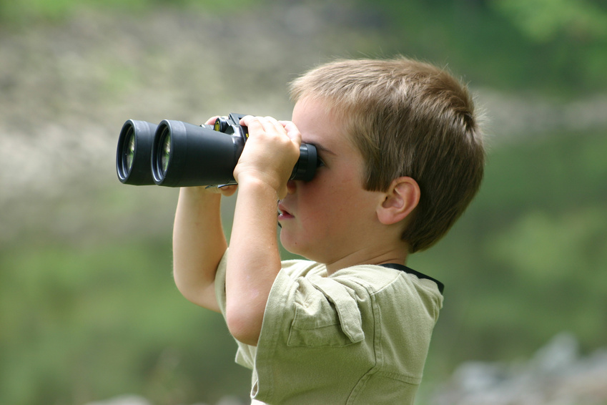  hop swim jump look  _________  _________  ________  _________ | go eat ride make  _________  ________  ___________  _________
Rhyming words: If the pair of words rhymes circle yes. If the pairs does not rhyme circle no
- bugs – rugs | yes no | - from - front | yes no
- go - to | yes no | - they – that | yes no
- ride - hide | yes no | - down - town | yes no
Name ____________________ “Where Do Frogs Come From” 4
Read the sentences. Circle right the ending. Then write it on the line.
- They help____ the frog jump away. | s ed ing
- Two frog____ ate the little bugs. | s ed ing
- What are you say____ to the frog? | s ed ing
- The tadpole is eat____ lots of plants. | s ed ing
- The boys are look____ for tadpoles. | s ed ing
Write the short vowel sounds for the pictures. a e i o u
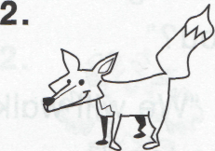
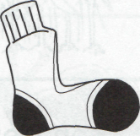
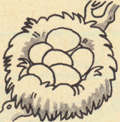
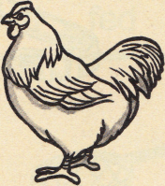

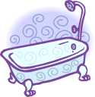
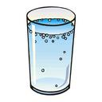
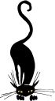
____ ____ ____ ____ ____ ____

____ ____ ____ ____ ____ ____
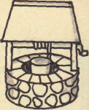
Classifying: Write the words that go with the first two.
- two to ______________ | too big
2. frog tadpole ______________ | nest eggs
3. jump hop ______________ | eat run

