Name _______________________ Did You See Chip? Bk. 1-3 1
Read the sentences. Circle the word that goes in the sentence. Then write it on the line.
- Kim and Dad are in the __________________ . | city | come
- __________________ I miss my bus. | Said | Sometimes
- They miss their farm __________________. | hide | house
- Let’s __________________ a walk in the park. | take | took
- Kim will be__________________. | they | there
Syllables = 1, 2 | Opposites: white ask go her
- sometimes_____  - city _____  - house _____  - may_____  - started _____  - look _____  - funny _____  - little_____  - not _____  - yellow _____ | - him _____________________  - come _____________________  - black _____________________  - said _____________________
Mean the Same: town worm jump insect
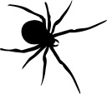
- hop _____________________
- bug _____________________
- caterpillar_____________________
- city _____________________
Name ________________________ Did You See Chip? Bk. 1-3 2
Read the sentences. Circle the word that goes in the sentence. Then write it on the line.
- I wish I had friends in the __________________. |  | city |  | could
- I don’t like my new __________________. |  | here | house
- Let’s __________________ Chip for a walk. |  | took | take
- That will __________________ us up. |  | cheer | climb
- We need to __________________ Chip |  | come | catch
Circle the noun and write it on the line. | Circle verb and write it on the lines.
house skip my cat tree  1________________________  2________________________  3________________________ | look our dog hop catch  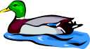  1________________________  2________________________  3________________________
Look at the pictures. Then match the sentences using the numbers.
- There is a worm  - The mother has  - The mouse likes  - The rabbit has | 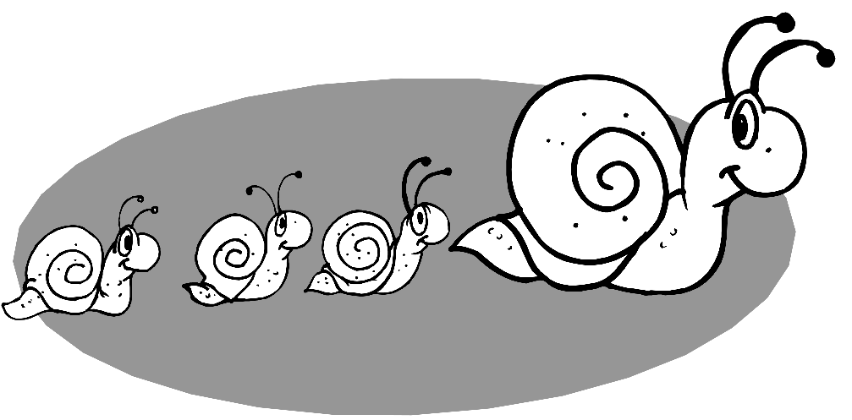  ____to paint.  ____in a book.  ____a big carrot.  ____three babies.

Name _________________________ Did You See Chip? Bk. 1-3 3
Read the sentences. Circle right the word. Then write it on the line.
- _________________ you see my dog, Chip? | Did | Down
- I _________________ he ran to the park. | think | thank
- Is he a little __________________ dog? | back | black
- I think he ran to the _________________. | sings | swings
- I will help you __________________ him. | catch | come
Compound words are two words put together make one word.
bow box fish  lunch______________  cat_______________  rain______________ |  | bus side thing  in_______________  any______________  school____________
Classifying: Write the word that go with the first two.
- red white ________________________ | jump
2. hop skip ________________________ | frog
3. tiny small________________________ | blue
4. cat bird ________________________ | little
Name _________________________ Did You See Chip? Bk. 1-3 4
Read the sentences. Circle right the ending. Then write it on the line.
- They help_____ look for Chip. | s ed ing
- I now have two new friend____ . | s ed ing
- What are they say_____ about Chip? | s ed ing
- Chip bark____ at the cat. | s ed ing
- My friends are look____ for Chip. | s ed ing
Write the short vowel sounds for the pictures. a e i o u
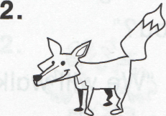
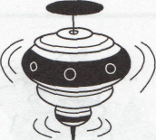

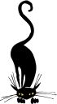

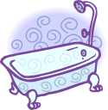
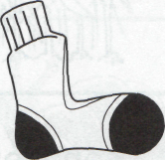
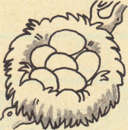
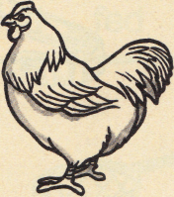
_____ _____ _____ _____ _____ _____

_____ _____ _____ _____ _____ _____

ABC Order. live chin inch art soon cart
1_______________________  2_______________________  3_______________________ | 4_______________________  5_______________________  6_______________________

