Name ___________________ Did You See Chip? Bk. 1-3 1
w
Read the sentences. Circle the word that goes in the sentence. Then write it on the line.
- Kim and Dad are in the ____ . | city | come
- ____ I miss my bus. | Said | Sometimes
- They miss their farm ____ . | hide | house
- Let’s ____ a walk in the park. | take | took
- Kim will be____ .  b  d | they | there
Syllables = 1, 2 | Opposites: white ask go her
- sometimes_____  - city _____  - house _____  - may_____  - started _____  m  - look _____  - funny _____  - little_____  - not _____  - yellow _____ | - him __________  - come __________  - black __________  - said __________
Mean the Same: town worm jump insect
- hop __________
- bug __________
- caterpillar__________
- city __________
Name ___________________ Did You See Chip? Bk. 1-3 2
l
Read the sentences. Circle the word that goes in the sentence. Then write it on the line.
- I wish I had friends in the _____ . |  | city |  | could
- I don’t like my new _____ . |  | here | house
- Let’s _____ Chip for a walk. |  | took | take
- That will _____ us up. |  | cheer | climb
- We need to _____ Chip  b  a |  | come | catch
Circle the noun and write it on the line. | Circle verb and write it on the lines.
house skip my cat tree  1__________  2__________  3__________ | 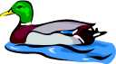  look our dog hop catch  1_________  2__________  3__________
Look at the pictures. Then match the sentences using the numbers.
u
- There is a worm  - The mother has  - The mouse likes  - The rabbit has | 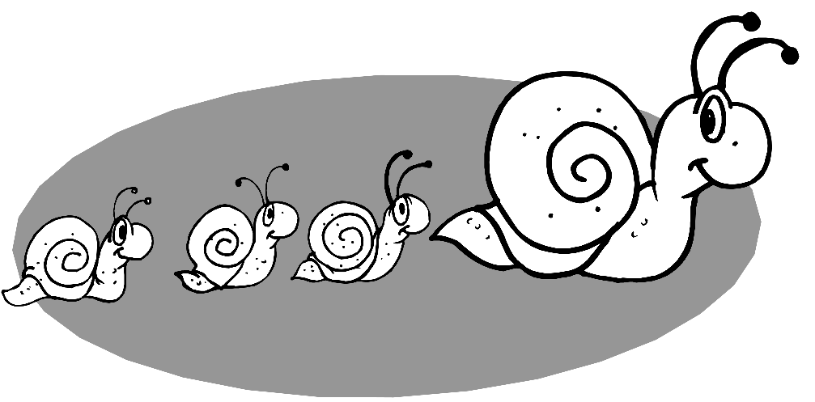  ____to paint.  ____in a book.  ____a big carrot.  ____three babies.
Name ___________________ Did You See Chip? Bk. 1-3 3
r
Read the sentences. Circle right the ending. Then write it on the line.
- _____ you see my dog, Chip? | Did | Down
- I _____ he ran to the park. | think | thank
- Is he a little _____ dog? | back | black
- I think he ran to the _____ . | sings | swings
- I will help you _____ him.  w | catch | come
Compound words are two words put together make one word.
lunch___  cat____  rain____  a | bow  box  fish | in_____  any____  school__ | bus  side  thing
Classifying: Write the word that go with the first two.
- red white ______ | jump
2. hop skip ______ | frog
3. tiny small ______ | blue
4. cat bird ______ | little
Name ___________________ Did You See Chip? Bk. 1-3 4
t
Read the sentences. Circle right the ending. Then write it on the line.
- They help_ look for Chip. | s ed ing
- I now have two new friend_ . | s ed ing
- What are they say_ about Chip? | s ed ing
- Chip bark_ at the cat. | s ed ing
- My friends are look_ for Chip.  n | s ed ing
Write the short vowel sounds for the pictures. a e i o u
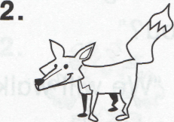
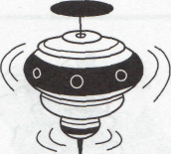
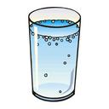
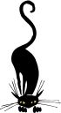
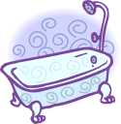
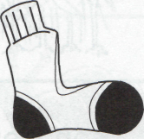
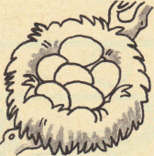
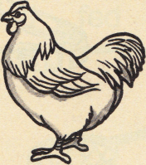
_ _ _ _ _ _
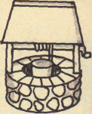
_ _ _ _ _ _
o
ABC order. live chin inch art soon cart
1________ | 4________
2________ | 5________
3________ | 6________

