Name ___________________ On the Way to the Pond 1
a
Read the sentences. Circle the word that goes in the sentence, then write it on the line.
- Herbert likes to ____ things. | first | find
- He saw ____ birds fly past. | for | four
- Where are ____ birds going? | these | them
- Let’s ____ them to the pond. | find | follow
- They ____ four little nests.  l | found | four
Match the Opposites. Circle the short u and i vowel words.
d
- find  - mother  - nice  - good | ___bad  ___mean  ___lost  ___father | 1. cut cute  2. mud hurt  3. your put  4. such found | 6. if high  7. first this  8. big bird  9. like his
BLENDS: MATCH - Write the number in the box that matches the word to the picture.
b
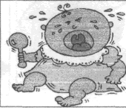  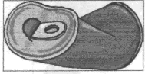  - plug  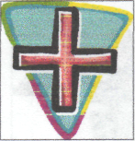  - cross  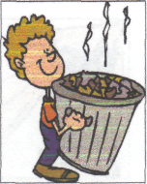  - crush  - cross  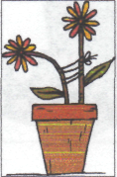  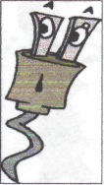  - plant  - trash | 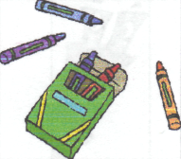  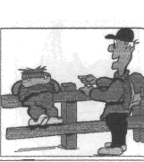  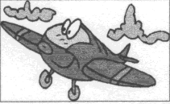  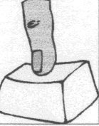 | - plane  - press  - globe  - climb  - clay  - crayons | 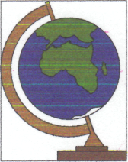  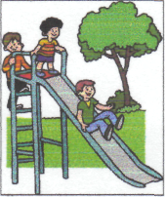  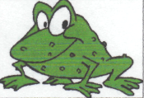

Name ___________________ On the Way to the Pond 2
a
Read the sentences. Circle the word that goes in the sentence. Then write it on the line.
- The nests were __ of baby birds. | full | four
- The little birds ___ hungry. | with | were
- The ____ was full of food. | blue | basket
- I will bring ____ four things. | these | take
- They ____ up the path. | say | started
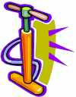

Match the word numbers to the pictures. Match compound words:
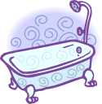  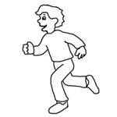  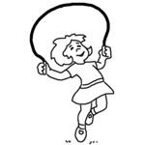  - plug  - pump  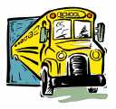  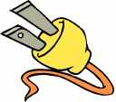  - tub  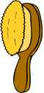  - bus  - brush  - jump  d | dog____  some____  out____  after____  gold ____ | fish  side  thing  house  noon
Match the naming part with the telling part to make a sentence.
- The girl ___has a baby.
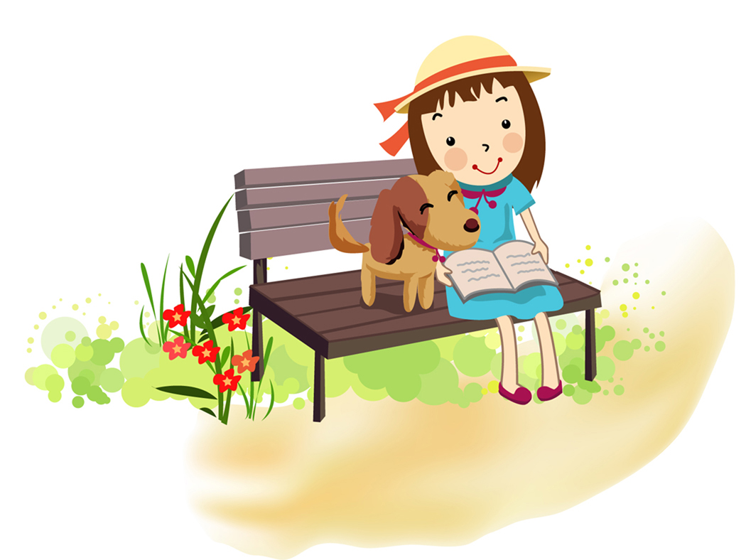
- The girls ___ is reading a book.
- A bird ___ are skating.
Name ___________________ On the Way to the Pond 3
a
h Write the two words for the contractions. n’t = not ‘ll = will ‘s = is
- Did you ____ my umbrella? | find | four
- All of a ___ Herbert stopped. | should | sudden
- Tess ___ the basket. | fish | forgot
- She ___ back to get it. | went | want
- She ___ the picnic basket. | found | food
T Make it more than one: Add s or es
- pond_  - wish _  - bird_ | - box_  - duck_  - bus_ | - book_  - dish_  - lunch_
s Use and to make two sentence into one sentence.
1. Herb will go back Herb will get it.
Herb will ____________
2. Tess will go to the pond. Herb will go to the pond.
__________ __________
_____________________
Name ___________________ On the Way to the Pond 4
a
Read the sentences. Circle right the ending. Then write it on the line.
- He follow_ the path home. | s ed ing
- Tess drop_ the rocks on the path. | s ed ing
- Herbert was look_ at the birds. | s ed ing
- He smile_ at the little birds. | s ed ing
- The birds are want_ more food.  t | s ed ing
Write the short vowel word for the pictures. a i o u e
_________  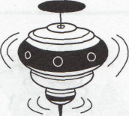  _________ _________  _________  o | 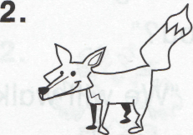  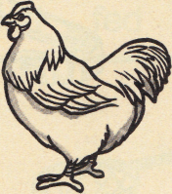  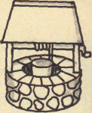  _________  _________  _________  _________
Classifying: Write the words that go with the first two.
- lunch picnic ______ | pond food
2. lake pond ______ | water dirt
3. four three ______ | too two

