Name ___________________ The Fox and the Stork Bk. 1-3 1
w
Read the sentences. Circle the word that goes in the sentence. Then write it on the line.
- ___ lives in the forest? | Who | Want
- Fox likes to play ___ . | takes | tricks
- ___ you like to come for dinner? | Who | Would
- How ___ of you to ask? | kind | find
- She tapped on the fox’s ___ .  b  n | door | down
Long o : Match –write the letter next to the word. ABC order
c
- goat__  a  b  - snow__  c  - soap__  - bow __  d  - road__  e  - bowl__  f |  | who would green goes gave  1.____________  2.____________  3._____________  4.____________  5._____________
Write the letter next to the two words for the contraction .
- I will ______  - they are _____  - she is______  - is not ______ | - they’re  - I’ll  - isn’t  -  She’s |  | 5.I am ______  6. they will_____  7. will not______  8. we are______ | - they’ll  - I’m  - we’re  - won’t
Name ___________________ The Fox and the Stork Bk. 1-3 2
w
Read the sentences. Circle the word that goes in the sentence, then write it on the line.
- Fox said he ___ soup. | make | made
- He ___ soup in a flat dish. | some | served
- Stork ___ eat from the flat dish. | couldn’t | could
- Fox soon ___ it all up. | slurped | sleep
- Fox ___ his boat to Stork’s house.  s | flew | rowed
Match the Opposites. Circle the short o and i vowel words.
d
- on  - his  - light  - good | ___her  ___bad  ___off  ___dark | 1. not note  2. in like  3. soap shot  4. hide hid | 6. rode rod  7. bottle boat  8. rob robe  9. light lit
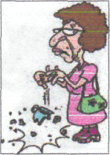
Write the beginning sounds for the pictures. br st sl cr fr tr cl
l
__ __ eak | 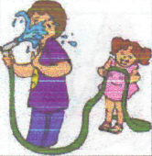  __ __ ick | __ __ ool
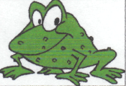  __ __ og | 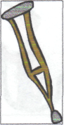  __ __ utch | __ __ oss
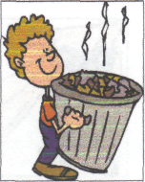  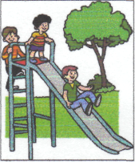  __ __ ash | 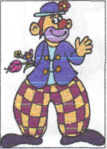  __ __ own | __ __ ide
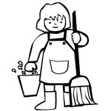
ame ___________________ The Fox and the Stork Bk. 1-3 3
k
Read the sentences. Circle the word that goes in the sentence. Then write it on the line.
- Stork uses greens grown in her ___ . | garden | goat
- Stork served her ___ in a tall jar. | cheese | soup
- All fox could do is ___ the top. | lick | look
- This is my ___ for tricking a friend. | help | reward
- Being kind is the ___ thing to do.  s  m | left | right
Syllables = 1, 2, 3 |  | Circle the word that goes  with the picture.
- soup__1__  - drinking____  - wonderful____  - garden____  - make____  g | - dinner____  - bowl____  - morning____  - popcorn____  - beautiful____ | 1. top toad
 |  | 2. snow soap
 |  | 3. road rod
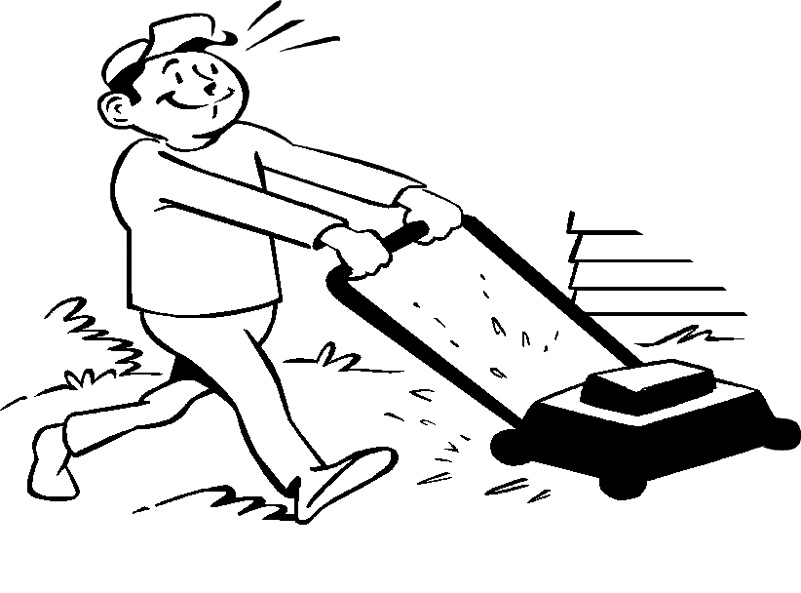
4. mop mow
 |  | 5. got goat
Add ed ing or s to the words.
- The friends are play_______ on the playground.
- Her cat hide_____ under the bush.
- Max help ____ Meg pick up the trash yesterday.
- The friends are pick _______ up the more trash today.
- They want_____ to help the animals.
Name __________________ The Fox and the Stork Bk. 1-3 4
q
H Read the sentences. Circle the word that goes in the sentence, then write it on the line.
- What did the ___ eat? | goat | boat
- Betty can run very ___ . | past | fast
- “Come here ___ ,” called Duck. | now | how
- Two ___ went into the house. | men | pen
- I saw ___ walking to school. | Mike | like
O If word means one- write 1. word means more than one write M. |  |  | t Write the word in the box: drill gum plum cuff tent log  s
1. buses___  2. road___  3. boats___ | 4. boxes___  5. foxes___  6. ship___ | 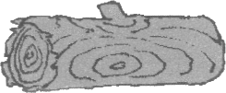  ______ |  | 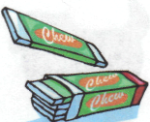  ______ | 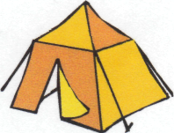  ______
1. buses___  2. road___  3. boats___ | 4. boxes___  5. foxes___  6. ship___ | 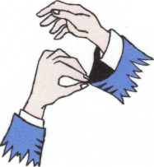  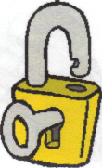  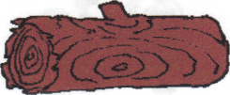  ______ |  | 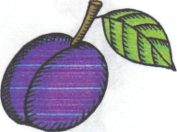  ______ | 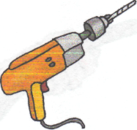  ______

Look at the pictures, then match the two parts of the sentences using numbers.
a
v
- The sly fox took  - The stork  - The fox  - A stork has  - The fox is | ___has fleas.  ___a baby.  ___ reading a book.  ___ the eggs.  ___ has a frog. | 