Name ______________________ Busy Buzzy Bees 1

H Read the sentences. Circle the word that goes in the sentence, then write it on the line.
- We see lots of bees in our ___________________. | wild
- They love the ___________________.flowers there. | wait
- The bees’ fuzzy legs ___________________.the flowers. | field
- The grubs __________________.for their food in the hive. | change
- Soon the grubs will ___________________.into bees.   | touch
Change the word to match the picture.
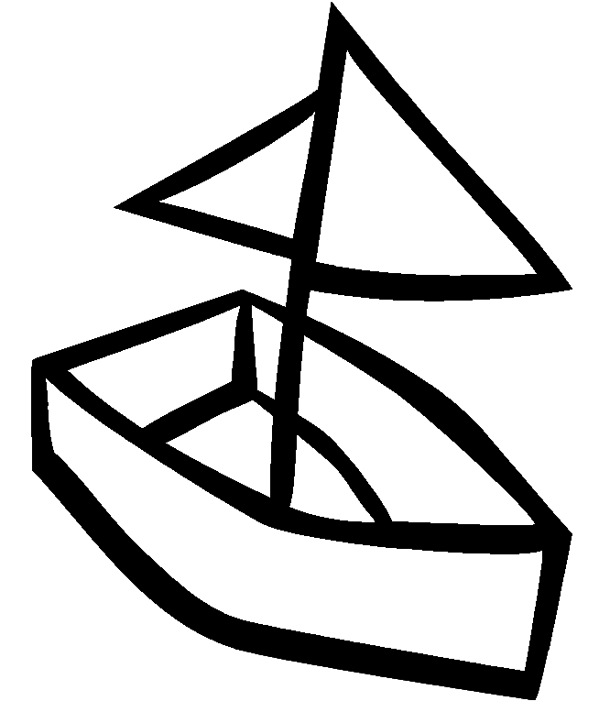  - coat to _____  - bit to _____  - dish to _____  - keep to _____ | 5. hit to _____  6. lake to _____  7. pin to _____  8. ball to _____

Match the verb to the subject.
✵
- Busy bee ____________ to the field.  - The grubs_______________legs and wings.  - They________________ from grubs to bees.  - She __________________in circle. | 1. fly flies  2. grow grows  3. change changes  4. crawl crawls
Name ______________________ Busy Buzzy Bees 2

Read the sentences. Find a right word in the box. Then write it on the line.
- There will be new bees in _________________ days. | grains
- Then there will be _________________bunch of bees. | queen
- Each flower holds _________________of pollen. | twelve
- The bees lap of _________________with their tongue. | nectar
- The _________________bee lays the eggs. | another
Means almost the same thing. Circle the word that is spelled correctly.
o
⇩

look shut tote town
- city _______________  - see _________________  - carry _________________  - close _________________ | - roze roose rose  - again agian agin  - bleu blue bloo  - thos thoose those  - bon bone boane

Analogies Example: Bird is to sky as fish is to water

1. In - out as hot - __________ 1. warm sun cold
2. dog - bark as bird - __________ 2. nap chirp fly
3. girl - Mom as boy - _________ 3. Dad pet sister
4. small – tiny as large - __________ 4. good little big

Name ______________________ Busy Buzzy Bees 3

Read the sentences. Find the word that goes in the sentence, then write it on the line.
- The _________________ bees are always males (boys). | thousands
- The queen bee lays _________________ of eggs. | grubs
- The bees make _________________ from the nectar. | twelve
- The _________________ are the baby bees. | drone
- In _________________ days the grubs turn into bees.     | honey
Compound Words Write the pronoun that can take the place of the nouns.

- ___________day  - ___________berries  - ___________way  - ___________ball | blue  base  to  drive | They She Her We  - Matt and I ___________  - Queen Bee ___________  - The bees and grubs __________  - Carla’s coat ___________
Circle the root or base words

- try tries tried  - bones bone boney  - roses rosey rose  - runner running run |  |  | - windy winds wind  - look looked looking  - plays playing played  - picked pick picking
Name ______________________ Busy Buzzy Bees 4

Read the group of sentences. Put the sentences in order by numbering 1, 2, 3
_____ A man helped me try on some shoes.
_____ The shoes fit so I took them home.
_____ Dad and I went to the shoe store.
_____ I ran to catch the bus.
_____ Mom got me up to get dressed.
_____ We had hotdogs for lunch.
Write the word and add ing | If 2 words same vowel sound = YES  If not = NO
- bake b_______________  - jump _______________  - vote _______________  - eat _______________   | rose - rode _______  blue - flew _______  code - cold ______  those - these _______  my - try _______


Put the words in order to make a sentence.
- Pam _________________________________________  - The fat cat __________________________________  - Sam can_____________________________________  - Jan has______________________________________ | 1.a cap had  2.has pal a  3. the bag pack  4. fat a ham

