Name_____________________ Nature Detective 1
k
Read the sentences. Circle the word that goes in the sentence, then write it on the line.
- A ____ looks for clues. |  | clues
- A ____ of torn clothing can be a clue. |  | nature
- All these____ helps the detective. |  | piece
- The ____ detective looks for clues in the yard.  r |  | floor
- You can find tracks on the kitchen ____ . |  | detective
Opposites: Write it on the line. | Classifying: skip arm paper yellow ran ball fox two
- night - ____  - come -____  - good -____  - in - ____  - play -____  - mom -____  - little -____  - new -____ | go  out  old  day  dad  big  bad  work | - run hop ____  - blue red ____  - six one ____  - pig duck ____  - leg nose ____  - bike kite ____  - man can ____  - pencil pen ____

Name_____________________ Nature Detective 2
b
k
Read the short story. Number them 1,2,3 in the right order.
_____ We buy milk from the store.
_____ The farmer milks the cows.
_____ Milk is put into cartons.
_____ Laura made a sandwich.
_____ Laura got out the bread
_____ Laura felt hungry.
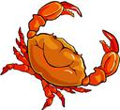
Write the short vowel sounds for the pictures . a e i o u
a

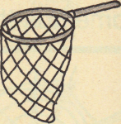

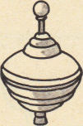

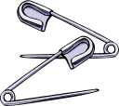

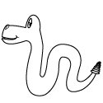
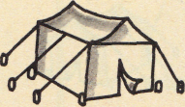
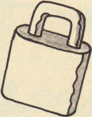
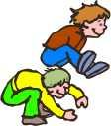
_ _ _ _ _ _
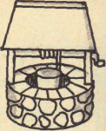

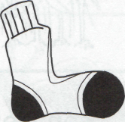
_ _ _ _ _ _
o
ABC order. old fold roll told find child
1________ | 4________
  2________ | 5________
3________ | 6________


Name_____________________ Nature Detective 3
h
k
Read the sentences. Find the write word and then write it on the line.
- A cat _____ his claws in when he walks. | clue
- A ____ can tell you which way the wind is blowing. | smell
- A good detective learns to look and _____ . | tracks
- ___ that someone has made can be a clue. | pulls
- You can find _______ in many places.  m  b | Marks
How many syllables do you hear? Compound Words:
o
1 2 or 3 yard self cakes prints
- detective ___  - where___  - something___  - find___  - fingerprints___ | - nature___  - drank___  - muddy___  - make___  - animal___  w | - foot _______  - back_______  - pan _______  - your _______
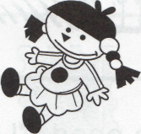  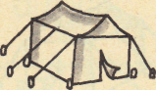  X out the word that does not go in the sentence. | Fill in the blank with the contractions:  hasn’t We’re can’t
- The dog fish ran to the pond.  - I will tell you when a story.  - The day rain will stop soon.  - I want spring dry to come soon.  - Baby how bears are called cubs. | - He ___ go to the pond.  - ___ going on a trip.  - Mama cat ___ had her kittens.
Name_____________________ Nature Detective 4
k
H Read the sentences. Circle the word that goes in the sentence, then write it on the line.
- Lucy ____ cookies at the festival. | row  cold  mow  sold  told  fold  bow
- Tim is sick with a ____ today | row  cold  mow  sold  told  fold  bow
- Carl will ____ clothes for Mom. | row  cold  mow  sold  told  fold  bow
- David ____ his class a great story. | row  cold  mow  sold  told  fold  bow
- Did you ____ the grass for Dad? | row  cold  mow  sold  told  fold  bow
S for short L for long vowel sounds |  |  | Contractions: Write the other words.
- hot____  - tree____  - roll____  - each____ | - went____  - drop____  - mole____  - cone____ | - we’ve-  - she’s-  - didn’t-  - they’ll- |  | we _______  she _______  did _______  they _______
a
s
Fill in the sentences with is are or am.
d
- Tom and Freddy ___________ camping out tonight.
- Frog ____________ helping Toad with his garden.
- I ___________ waiting for a letter from Grandma.
- This ___________ an Alaskan brown bear.
- I _________________ a nature detective.

