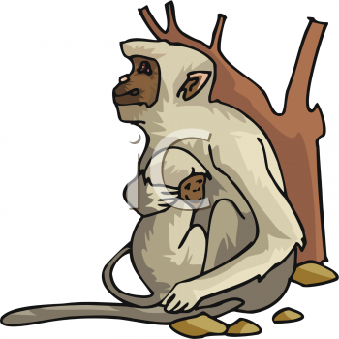
Name ___________________________ Baboon 1
g
Read the sentences. Find the word to finish the compound word. Then write it on the line.
- Baboon saw a _____ in the forest. |  | quietly  fire shook against careful
- They watched it _____ . |  | quietly  fire shook against careful
- We must be _____ around fires. |  | quietly  fire shook against careful
- The elephants _____ the ground as they walked by. |  | quietly  fire shook against careful
- The baby leaned _____ his mother.  p  k |  | quietly  fire shook against careful
Match words that go together. | Circle verb and write it on the lines.
- pots and _____  - soap and_____  - ham and_____  - peas and _____  - rod and _____  n | reel  eggs  cats  arrow  water  carrots | look hole hold jump pony hut  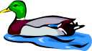  1_________  2__________  3__________
Sequence: Put the story in order. 1, 2, 3, 4,
_____ Roy put away his paints.
1
_____Roy got out his paint set.
_____ Then he painted a nest for the bird.
_____He painted a picture of a bird.
Name ___________________________ Baboon 2
t
Read the sentences. Circle the word that goes in the sentence, then write it on the line.
- Baboon _____ from his mother’s back. |  | heat
- A turtle sat in the ____ of the road. |  | watched
- Baboon ______ for the turtle. |  | middle
- He could feel the ____ from the fire. |  | Careful
- _____ , the crocodile might eat you.  a  c |  | slid
Means the same: Write it on the line. | Similes – words that describe by comparison:  bone ice grass button glass pig honey fox
- like - ____  - part -____  - good -____  - call - ____  - look -____  - stop -____  - run - ____  - carry -____ | nice  tote  enjoy  see  trot  piece  shout  end | - as fat as a ____  - as cute as a ____  - as sweet as ____  - as green as ____  - as sly as a ____  - as cold as ____  - as smooth as ____  - as dry as a ____
Name ___________________________ Baboon 3
s
Read the sentences. Find the word that will take the place of the underline words. Then write it on the line.
- They _____ loud and shook the ground. | darted tall  quick  read  disappear thundered
- A gazelle was _____ and fast. | darted tall  quick  read  disappear thundered
- A rhinoceros _____ out of the bushed. | darted tall  quick  read  disappear thundered
- The baboon hid in the _____ grass. | darted tall  quick  read  disappear thundered
- Baboon watched the sun _____ behind the trees.  l  f | darted tall  quick  read  disappear thundered
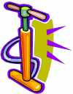

Match the vowel sounds in these words. Write the words in ABC order.
d
- tame ___  - shark ___  - show ___  - jump ____  - frog ____    - boy ____ | - soil  - clock  - plug  - rain  - heart  - cold | tool  cool  boot  head  toot | - ____  - ____  - ____  - ____  - ____
Circle the common nouns and write the nouns on the lines.
- The duck swam in the lake. _____ _____
- We have a new ball and bat. _____ _____
- He left his coat on the chair. _____ _____

Name ___________________________ Baboon 4
o
Read the sentences. Circle the contraction, then write the two words on the lines.
- Baboon hasn’t gone to sleep yet. | ___ ___
- He didn’t follow his mother home. | ___ ___
- The elephants weren’t by the river. | ___ ___
- Baboon didn’t climb up the tree. | ___ ___
- The fire isn’t raging anymore.  k | ___ ___
Write the beginning sounds (blends) and vowel sounds for the pictures to finish spelling the word.
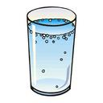  1. ______ss    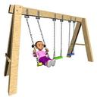  2. __ ___m _  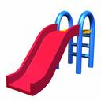  3. __ _ ___ng  4. _______de  w  a |  | 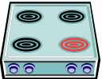  5. ____ _ve_  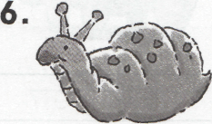    6. _____ ___il_  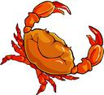  7. _______ne  8. ________ b
Match the words with the pronouns. |  | Circle the word that is spelled correctly.
- boys and girls___  - at the park___  - Aunt Sue___  - Bob and me___  - Dr. Fred Brown___  - the firedog___ | a. there  b. us  d. it  e. they  f. she  g. he | 1. cloo | cool | colo
 | a. there  b. us  d. it  e. they  f. she  g. he | 2. tolo | tool | tloo
 | a. there  b. us  d. it  e. they  f. she  g. he | 3. head | haed | heda
 | a. there  b. us  d. it  e. they  f. she  g. he | 4. caryr | caray | carry
 | a. there  b. us  d. it  e. they  f. she  g. he | 5. totoh | totho | tooth

