Name ____________________________Jack and Rick 1

Read the sentences. Circle the word that goes in the sentence. Then write it on the line.
- Jack and Rick __________to play. | will | want
- Can Jack __________up the log? | play | pick
- No! It is ____________big! | too | to
- Can Rick ____________Jack? | here | help
- Yes! Rick can __________the rope. | pass | red
- Can they ____________it now?     | look | lift
Who is Who???? Write the rhyming words.
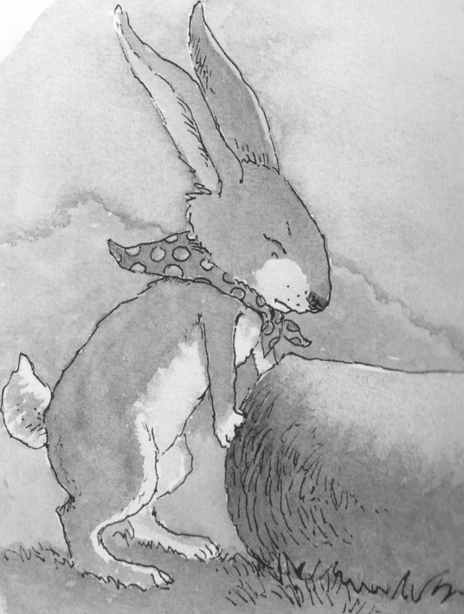  Jack Sam Rick  _______ | back  _______ | pick  _______
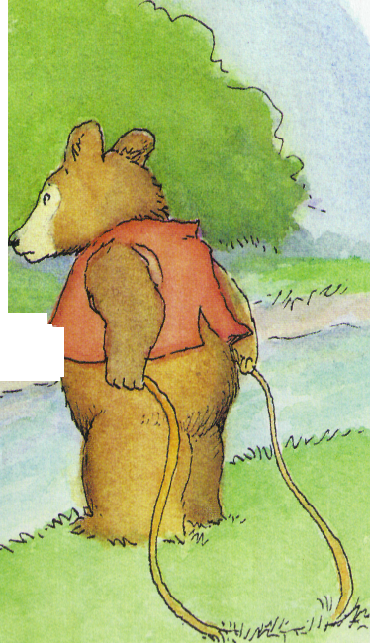  Sam Jack Rick  ____ | pig  _______ | 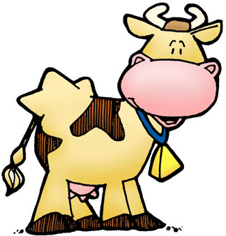  now  _______
Write the sentence correctly. Put a . or ? in the box.
1 sam will help rick
Sam________________________________________

________________________________________________

2. will jack find pam
Will __________________________________________
________________________________________________

Name ___________________________ Jack and Rick 2

Read the sentences. Circle the word that goes in the sentence. Then write it on the line.
- Yes, ____________can lift it now. | two | they
- Can Rick ____________to Jack? | funny | walk
- No! ___________, no! Help Rick! | Oh | away
- Can Jack ____________Rick now? | down | help
- Yes, Jack can help Rick _________. | funny | now
- Now Jack and Rick can _________.   | play | here
Write the words in ABC order.
pick sick tack  1________  2________  3________ | now too want  1________  2________  3________ | walk they big  1________  2________  3________
Unscramble and write the sentence correctly.
1 now jack and rick can play
Now___________________________________________________________

2. yes, jack can help
Yes,__________________________________________________________

_______________________________________________________________

⇩
Name ___________________________ Jack and Rick 3
Read the sentences. Circle the word that goes in the sentence, then write it on the line.
- Rick is a ____________bear. | make | funny
- Jack ____________a rabbit. | is | in
- Jack and Rick can __________ball. | little | play
- Pam will ____________up and down. | jump | they
- Can Dan help the________ little ants?    | little | look
Say the pictures with your teacher, then draw a line to match the pictures with the words.
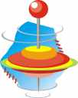  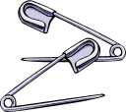  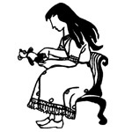 | _spin_  _pin_  _pig_  _witch_  _chin_  _sit_ | 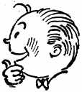 | 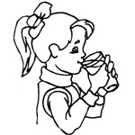  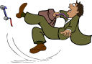 | _ship_ _slip_  _fish_  _swing_  _drink_  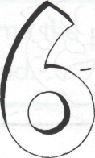  _kick_ | 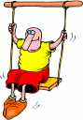
Teacher will read the definitions and Check the telling sentences!!
→
students will match words to the definitions.
&
too want now  ___ At this time  ___ Also, more  ___ To hope for | √ the telling sentences  ____ Can you help me?  ____ He is in the bag.    ____ I can help you.  ____ The funny cat hat.  ____ The red hat is for you.
Name ___________________________ Jack and Rick 4

Read the sentences. Circle the word that goes in the sentence. Then write it on the line.
- They will help the __________pig. | sick | said
- We will ___________up the little pig. | play | pick
- Nick will pack a ___________for the pig. | see | sack
- The ____________pig wants to play. | big | can
- Is the ____________is in the sack? | tack | they
- Sid will ____________a wig in a sack.   | walk | win
Listen to the vowel sound. Write an a or _i under the correct picture to match the sound.
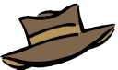
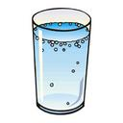
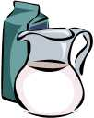
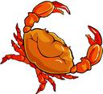
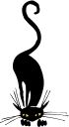

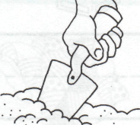
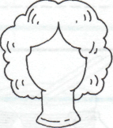
____ ____ ____ ____ ____ ____

____ ____ ____ ____ ____ ____


Read the sentences. Circle the one that is written correctly
1. can rick Walk to jack?  2. Can Rick walk to Jack? | 1. Max and Rick want to play.  2. max and rick want to play?
- Now Jack and Rick can play.  - now Jack and rick can play? | - pam want to play, too?  - Pam wants to play, too.

