Name __________________________ PP Sam and the Bag 1
Read the sentences. Circle the word that goes in the sentence, then write it on the line.

- Sam ran up ________down. | away and
- ________Sam! Help the cat. | Oh Got
- Can you go ________the bag? | in it
- ________, you can. | And Yes
- Max ran in the ________. | big bag
- Max and Hap can ________in.   | jump blue
Say the pictures with your teacher, then circle or color the pictures that have the short a sound.
ă |  | 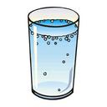  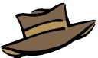  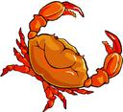
Trace over the letters and then write the missing letter.

a ___ c | x ___ z
h ____ j | m ___ o
Name __________________________ PP Sam and the Bag 2

Read the sentences. Circle the word that goes in the sentence. Then write it on the line.
- Max ran ________ the bag. | in | it
- Hap ran in the ________ . | got | bag
- Sam ran ________ the bag. | up | is
- Sam ran ________ the bag. | go | down
- Can Sam ________ in? | yes | go
- ________ Sam can go in.   | Yes | Blue
Say the pictures with your teacher, then circle 8 pictures that have the sl sound.
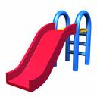  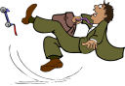  sl | 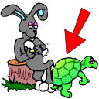  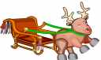 | 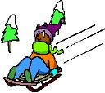  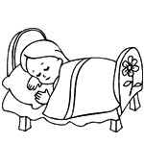
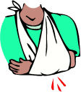
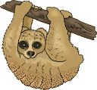
Read the sentences. Circle the one that makes sense.

1. I am Max  2. Max I am. | 1. Up can Sam go.  2. Sam can go up. | 1. Hap can jump in.  2. Can jump Hap in.
1. Hat has a Pam.  2. Pam has a hat. | 1. Jump up Max can.  2. Max can jump up. | 1. Dan got the hat.  2. Hat got Dan the.
Name __________________________ Sam and the Bag 3

Read the sentences. Circle the word that goes in the sentence. Then write it on the line.
- Can Dan ________Sam? | here | help
- The cat ________away. | can | ran
- Dan ________the cat. | got | go
- Can Pam ________the hat? | find | big
- Sam, come and ________Max. | funny | help
- Max can go down ________.   | here | oh
Write the rhyming words. fl, r, cl, m, b, c,
tap  ____ ap | tap  ____ ap | 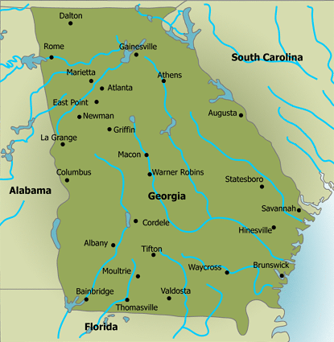  tap  ____ ap
tag  ____ ap   |   tag  ____ ap | tag  ____ ap
Unscramble and write the sentence correctly.
1 Dan hat the got.
Dan _________________________________

2. Sam bag ran down the.
Sam__________________________________

Name __________________________ Sam and the Bag 4
☺
Read the sentences. Circle the word that goes in the sentence. Then write it on the line.
- Sam helps the ________cat. | here | funny
- Yes, Pam can go ________. | oh | here
- Funny Max _______in the hat. | ran | is
- The _______cat sat on the rat. | big | away
- Max, the cat ______on the mat. | blue | sat
- Pam ran up and ________   | go | down
Write the words in ABC order.
bag cap am  1________  2________  3________   | ham mad tap  1________  2________  3________ | cat at hat  1________  2________  3________
Unscramble and write the sentence correctly.
1 Can the go in bag Max.
Can_____________________________

2. Hap in bag the ran.
Hap_____________________________

