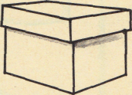
Name __________________________ PP Todd’s Box 1E
Read the sentences. Circle the word that goes in the sentence. Then write it on the line.
- Look , Mom! I can _____ . | don’t | dig
- I can dig in the _____ . | said | sand
- Not _____ , Todd. | now | my
- Hop ____ the rocks, Todd . | off | one
- Look, Mom! The ant is __ fast. | see | So
- I ____ picking up rocks. | all | am
- We ____ want to play now. | down | don’t
Write the missing vowel o or i
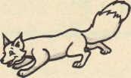  f__ x | 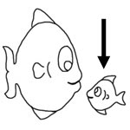  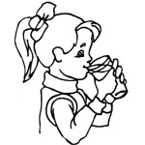  _f sh_ | 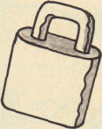  l ck
_fr___g | _dr_nk__ |   _qu_ lt_
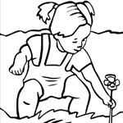  _d__g | _k_ ck | 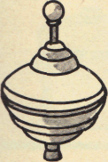  _t__p

Name __________________________ PP Todd’s Box 2 -E
Read the sentences. Circle the word that goes in the sentence. Then write it on the line.
- Don’t _____ up the ant, Todd! | pick | play
- Look at the _____ , Mom. | pond | little
- We _____ to go home, Todd. | come | have
- Mom, here is a _____ for you. | come | gift
- It is a _____ of ants, Mom. | box | Blue
- Here _____ a little ant. | come | comes
- I can _____ with Todd. | play | plays
Listen to the vowel sound. Write an o or _i under the correct picture to match the sound.
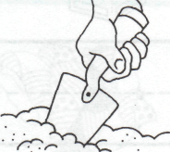
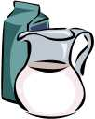
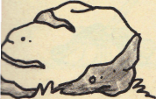
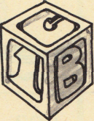
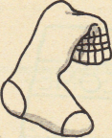
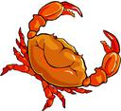
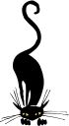
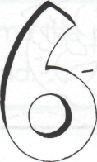
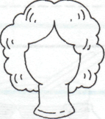
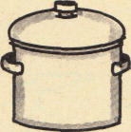
_ _ _ _ _ _
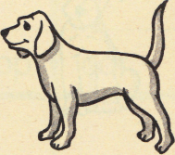
_ _ _ _ _ _
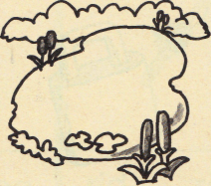
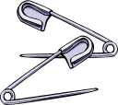

_ _ _ _ _ _
Name __________________________ PP Todd’s Box 3-E
Read the sentences. Circle the word that goes in the sentence, then write it on the line.
- ____ play in the sand. | I’ll | He’s
- The cats ____ like to play | she ’ll | don’t
- ____ jump in the pond. | He’ll | She’s
- They ____ like to play in the sand | she’ll | don’t
- ____ jump on the bed. | Here’s | Don’t
- We ____ have to go now. | don’t | I’ll
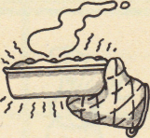
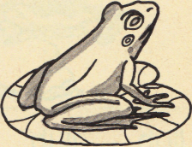
Ŏ

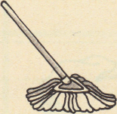

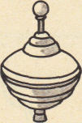 |  | 
Say the pictures with your teacher, then circle or color the pictures that have the short o sound.

Name __________________________ PP Todd’s Box 4-E
Read the sentences. Circle the word that goes in the sentence. Then write it on the line.
- Don’t sit on the ______ . | box | hot
- Do you ______ the i ? | not | dot
- Sam will ______ up the ants. | stick | pick
- Mom dropped the hot _____ . | not | pot
- Todd is ______ now. | back | Tack
- Rick can _____ to the rock. | hop | now
- Don’t _____ the bag, Sam. | not | pop
Write the vowel sounds for the pictures. a o i


     

     

