To: Local Unit Presidents, Presidents-elect, and Area Directors
From: Public Information/Program Planning Committee
Cynthia Ables, Chair
Subject: Retired Educators Day (November 7, 2010)
Enclosed is the promotional material for GEORGIA RETIRED EDUCATORS DAY, November 7, 2010. The packet includes:
- A copy of the State Proclamation signed by Gov. Perdue
- A sample copy of a Local Proclamation
- Retired Educators Day Flyer/Bulletin Insert
- Suggestions to promote RETIRED EDUCATORS DAY
These materials are being sent for your use in recognizing Retired Educators Day in your city and county. Enclosed materials may be reproduced in any quantity needed.
Let us work together to create a greater awareness of the contributions of GREA and retired educators in local communities. Let us know if we can be of further assistance. Thank you for all you do on behalf of Georgia Retired Educators Association.

BY THE MAYOR OF THE CITY OF____________________, GEORGIA

OR

BY THE CHAIRMAN OF THE BOARD OF COMMISSIONERS,
COUNTY OF_________________________, GEORGIA
WHEREAS: The Governor of the State of Georgia has proclaimed the day of Sunday November 7, 2010 as Retired Educators Day in Georgia; and
WHEREAS: There are more than 82,000 retired educators in Georgia, 20,500+ of whom are members of the Georgia Retired Educators Association; and
WHEREAS: The retired educators of Georgia donate thousands of hours of volunteer service and make invaluable contributions to the welfare of their respective communities across the state; and
WHEREAS: It is appropriate that a day be designated for citizens to express their appreciation for the contributions that retired educators have made and continue to make for the betterment of human lives and for society; and
WHEREAS: Local churches will recognize those lasting contributions made by retired educators in this community; now
THEREFORE: I, Mayor (or Chairman) of_________________________________
_____________(City or County) do hereby proclaim the day of November 7, 2010, as
"RETIRED EDUCATORS DAY" and I call upon the citizens of__________________
to observe that day in an appropriate manner honoring retired educators.
Given unto my hand and seal at , Georgia, on this_____day of
, in the year of our Lord, 2010.

___________________________________

Mayor (or Chairman)

ATTEST

______________________________________ (Name and/or Title)


BY THE GOVERNOR OF THE STATE OF GEORGIA
A PROCLAMATION
RETIRED EDUCATORS DAY
WHEREAS: More than 86,000 retired educators have devoted their time, energies and talents to public education, providing the educational development of millions of outstanding Georgia citizens; and
WHEREAS: Retired educators touched and influenced the lives of generations of young people and motivated and inspired them to use their innate talents and abilities to the fullest and to become responsible and contributing citizens; and
WHEREAS: Retired educators possess valuable knowledge and use their lifetime experiences and skills to enrich the educational process in a variety of settings. They often continue to be a major source of insight and direction for our state and our nation. Many continue to serve in religious, civic and political organizations; and
WHEREAS: For over 52 years, the Georgia Retired Educators Association has dedicated its efforts to improving the welfare to retired educators and has provided opportunities for them to become involved in community activities; and
WHEREAS: All citizens of Georgia owe a debt of gratitude and appreciation to retired educators for their dedicated service to our state and nation; now
THEREFORE: I, SONNY PERDUE, Governor of the State of Georgia, do hereby proclaim November 7, 2010, as RETIRED EDUCATORS DAY in Georgia and urge our citizens to recognize the lasting contributions of our state's retired educators.
In witness thereof, I have hereunto set my hand and caused the Seal of the Executive Department to be affixed this 9th day of September in the year of our Lord two thousand ten.

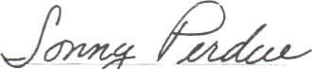

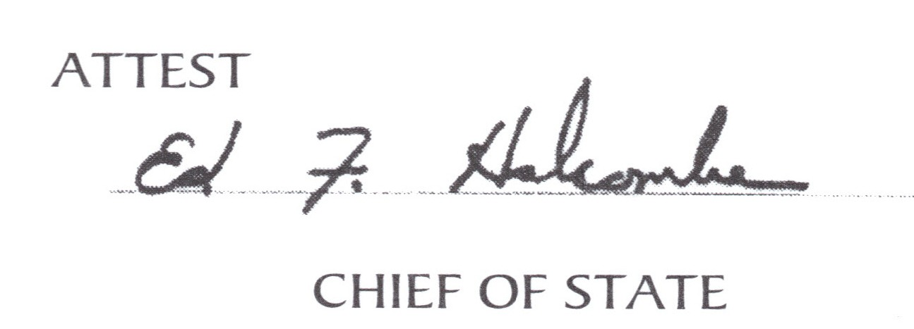
GOVERNOR

Suggestions for Promotion of GRE Day
- GRE Day activities meet requirements for Unit of Excellence Organizational Section-
Standard 3.
- GRE Day activities do not have to be done by one person - delegate! Activities can
be coordinated by Public Relations Committee or a special Retired Educators Day
Committee.
- Contact your local city/county government for a Local Proclamation. Attend meeting
where Proclamation is presented to Local Unit President (or representative of Local
Unit). Don't forget to take a picture. Since GRE Day is November 7, 2010, the
Proclamation must be done at October government meeting. Contact in September to
learn when your local government meets. Some meet first week of month.
- Contact local newspaper for article/picture. Contact local radio and TV stations for
announcements. Provide typed information. Publicize local volunteer hours for year.
- Contact schools, churches, banks, restaurants, and other businesses to have
information placed on signs and marquees.
- Members should contact their churches to have information put in church
newsletter/bulletin on November 7. Use enclosed bulletin insert. Ask pastor to
recognize retired educators in congregation.
- Suggested activities for November 7, 2010
  - Attend church as a group.
  - Have a reception or luncheon for your Local Unit. These can be
sponsored by a local school, school system, bank, or other business,
  - Group or individuals can visit "shut-in" retired educators. A small gift
would make the day special.
- Make pictures of signs/marquees and activities. Obtain copies of news articles.
These are needed for Scrapbook and for Public Relations Award (due March 1).

